Cover page

Table of Contents

1. Executive Summary: 1

2. Introduction: 1

3. Project Management: 3

Gantt Chart: 3

Team Roles: 4

4. Research: 5

Technical Research: 5

Weed Removal Methods 5

Chassis Considerations 6

Power Considerations 7

Navigation 8

Image Processing And AI/ML 9

Industry Examples 11

Market Research: 11

Brazil 11

Weeds 13

Weed Management 14

Existing Products 15

First Hand Market Research 16

Cultural, Societal, Diversity & Inclusion Factors: 16

Cultural Factors 16

Societal Factors 17

Diversity and Inclusion Factors 17

Environmental Sustainability of Product Sector: 17

5. Design: 18

Description of design process and evaluation criteria identified: 18

Design informed by market analysis: 22

Detailed CAD and Electronics Design: 25

6. Modelling & Analysis: 25

FEA: 25

Explanation of test cases and loads 25

FEA Analysis 26

Concluding Remarks 29

7. Prototyping: 30

Prototype Processing Plan: 31

List of Part and Budget: 32

Evaluation of the prototype: 33

8. Manufacturing: 34

Manufacturing Requirements: 34

Parts List 34

Supply chain 35

Suppliers 35

Analysis of Manufacturing Global Options: 36

Manufacturing Process: 40

9. Business Plan: 44

Business Model Canvas: 44

Customer Segment 44

Value Propositions 45

Channels 45

SWOT Analysis: 46

Strengths 46

Weaknesses   46

Opportunities 46

Threats   47

Exploration of potential markets: 47

Finance Projections: 48

Critical Analysis of Risks: 50

10. Next Steps: 53

11. References: 54

12. Appendices: 54

Appendix 1: 54

Appendix 2: 54

# **Executive Summary:**

This report presents the development process for an innovative robot designed to remove weeds autonomously in Brazilian coffee crop fields. The purpose of this project, undertaken by Activelio AgriTech, is to provide a solution for weed control without the use of herbicides. Simultaneously, the robot aims to enhance crop yields and minimize environmental impact.

The report commences by providing an in-depth overview of current weed management practices prevalent in the industry, focusing specifically on the Brazilian context. It explores the cultural and societal factors that influence the adoption and success of novel agricultural products in this region.

The design phase of the project is thoroughly discussed, showcasing the entire process from concept generation and selection to the final design of the product. Key features, such as the rocker-bogie wheel base and laser-based weed removal system, are highlighted. Additionally, Finite Element Analysis (FEA) modelling techniques are employed to optimize the design.

The prototyping stage is also covers the differences between the prototype and the final commercial product. The prototype primarily showcases the unique selling point of the rocker-bogie design which is aim to robust and easy to fix for rural farmers.

The manufacturing section of the report outlines the chosen suppliers and manufacturing processes to be employed at the Activelio AgriTech facility. An analysis of global manufacturing options was conducted, with the United Kingdom being selected as the most favourable country for production. Furthermore, a thorough Life Cycle Assessment (LCA) was conducted, indicating that the robot needs to operate for approximately 1.2 years to achieve a positive environmental impact.

Moreover, the report contains a business plan incorporating various strategic frameworks such as the Business Model Canvas (BMC) and SWOT analysis. These frameworks shed light on the strategic approaches employed by Activelio AgriTech to maximise commercial success. Market potential is explored through analyses of the Total Addressable Market (TAM), Serviceable Available Market (SAM), and Serviceable Obtainable Market (SOM), projecting a serviceable market worth £20 million within a 10-year timeframe.

Financial projections within the report demonstrate the profitability of Activelio AgriTech, with estimates indicating that the company will achieve profitability in its second year of operation, generating a net profit exceeding £400,00. Additionally, seed round investors can anticipate a return on investment (ROI) of 19X, while Series A investors can expect an ROI of 7X.

# **Introduction:**

Weeds threaten to lower crop yields and therefore pose a major problem to farmers around the world. They compete with crops for space, sunlight, nutrients, and minerals, while also serving as hosts to pests and diseases when left unchecked. Weed management in Brazil is particularly challenging due to the country’s diverse array of habitats and terrains, ranging from temperate grasslands to tropical rainforests. Developing a practical and cost-effective strategy to resolve this issue is key when seeking to protect one of its most important crops, coffee. The South American nation is heavily reliant on coffee cultivation, which contributes upwards of 41.28 billion dollars [1] annually to Brazil’s economy, or roughly 3.21% of the country’s GDP in 2021 [2], making it the largest producer and exporter in the world. Weeds may also indirectly threaten another of Brazil’s vital lifelines: The Amazon Rainforest. As yields reduce in size and quality as a result of competition from weeds, more land is required to recoup these losses, thus contributing to the rapid growth of deforestation in the region, further adding to climate change and transforming it into a global issue. This problem is made worse by the fact that traditional weed management strategies are often labour-intensive, costly, and can sometimes be harmful to the environment. Manual weeding requires a large workforce, while Brazil’s main method of weed control, chemical herbicides, can be toxic and costly for small-hold farmers to procure. Many of the farmer’s involved in Brazil’s coffee industry operate on small, family run farms, thus making it even harder to generate a profit off their small margins.

By introducing autonomous processes to such tasks greatly reduces the farmer’s reliance on such methods and has the potential to greatly improve crop yields. Designed for South America’s harsh and unforgiving terrain, the weed-removing robot to be described in this report was developed to tackle this problem in the most innovative, pragmatic, and cost-effective manner possible. By effectively removing weeds without the need for human supervision, the farmer’s costs are reduced, and their yields increased, in turn improving revenue generation and allowing the farmers to reinvest these profits into their farms and communities, thus leading to economic prosperity. The increased use of autonomous machines in the agricultural sector is expected to open up a previously untapped market for such products. Farmers will become more familiar with the benefits of using such technologies, making them more likely to further invest in other forms of automation that perform tasks other than weed control. This development will drive innovation in the sector and create new opportunities for business such as Activelio AgriTech.

Therefore, at Activelio AgriTech, our mission is to transform the obsolescent farming industry by creating an agricultural rover with the features of weed control, autonomous driving, and environmental sensing. With the combined features through the latest technologies in laser, single-board computers (SBCs), camera modules, and ultrasonic sensors, our weed control autonomous rover can perform its missions of “effectively removing weeds without the need for human supervision” to the state-of-the-art, all of which a farmer would love to acquire.

# **Project Management:**

## Gantt Chart:

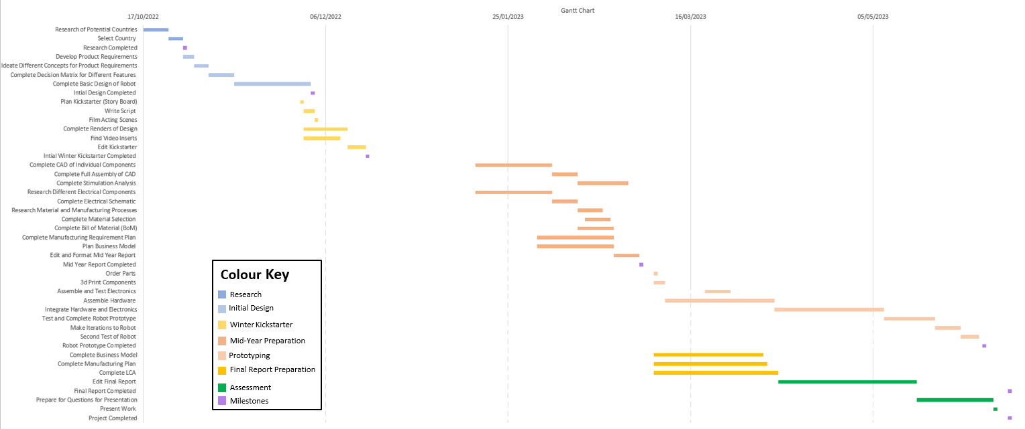

Figure 1 - Project Gantt Chart

## Team Roles:

Activelio consists of 6 group members all coming from a diverse range of educational backgrounds as shown in Table 1. In playing to this strength, each member was given a specific role within this project based on their background and skill set.

Table 1 - Team Members, Educational Backgrounds, and Roles

|  |  |  |
| --- | --- | --- |
| **Name:** | **Undergraduate Studies:** | **Role:** |
| Amal Ahmed | Mechatronics Engineering | Electronics and Control Lead |
| Yu Bo | Mechanical Engineering | Business Lead |
| Jason Sofianos | Mechanical Engineering | Project Management and Simulations Lead |
| Yachun Li | Mechanical Engineering | Design Lead |
| Jimmy To | Aerospace Engineering | Prototype Lead |
| Omar Al-Maaytah | Manufacturing Engineering | Manufacturing and Costing Lead |

Figure 1 presents the Gantt chart employed throughout the project, providing a visual representation of task allocation based on the specific roles of team members. This planned chart includes essential milestones, which serve as significant markers throughout the project timeline. These milestones include:

* Completion of research
* Completion of initial design
* Completion of Winter Kickstarter
* Completion of Mid-Year Report
* Completion of Robot Prototype
* Completion of Final report
* Completion of Project

Contingencies were used through the project, to ensure momentum was maintained within the project as shown in Table 2.

Table 2 - Project Contingency Plans

|  |  |
| --- | --- |
| **Contingencies** | **Applied (Y/N)** |
| If both motion and laser system fails to operate after the second iteration of development, focus will be redirected to ensure that only the laser system operates correctly during the demonstration. | **N** |
| If unable to purchase components from university recommended suppliers such as RS and Farnell, team will purchase components from Amazon and Ebay. | **Y** |
| If 3D printers at Mechspace are unavailable, 3rd party 3d printing services will be used such as 3DPRINTUK | **N** |
| If unable to use acrylic for body panels, other materials will be used like wood and steel. | **N** |
| If unable to source raspberry Pi, focus will be redirected to Arduino usage only. | **Y** |
| If unable to integrate robot to AI, both will be developed and presented separately. | **Y** |

# **Research:**

## Technical Research:

Automated weeding provides a more efficient, precise, and sustainable solution for weed management in agriculture. It enhances efficiency by covering large areas quickly and operates continuously, reducing labour costs. Advanced technologies enable these machines to accurately identify and target weeds, minimizing crop damage. Automated weeding also promotes environmental sustainability by eliminating the need for chemical herbicides, reducing soil and water pollution, and supporting biodiversity. It also improves safety by minimizing farm workers' exposure to harmful chemicals. Therefore, automated weeding represents a significant advancement in agricultural practices, offering a sustainable and efficient approach to weed management.

### Weed Removal Methods

**Mechanical weeding** involves tools or machinery, like a robotic arm, to physically remove weeds. It's environmentally friendly and effective against larger weeds. It can also improve soil quality through aeration and the addition of organic matter. However, it can be labour-intensive and less effective on smaller or deep-rooted weeds and has an additional risk of crop damage if machinery isn't well-controlled, and frequent use could lead to soil erosion .

**Thermal weeding**, utilizes high temperatures, either through the use of flame or steam, to eradicate weeds. This method has proven efficacy against typical annual and biennial weed species and can effectively target challenging areas, such as the narrow spaces between coffee plants or cracks in plantation paths. Nevertheless, it necessitates a substantial amount of energy, raising potential concerns for extensive plantations. Moreover, there is an inherent fire hazard, particularly during dry seasons. It is also important to note that thermal weeding has the potential to harm beneficial insects and other organisms within the plantation's ecosystem. Additionally, it may not entirely eradicate perennial weeds that possess deep-rooted systems. (https://www.researchgate.net/publication/281496040_Thermal_weed_control)

**Electrical Weeding** is another method which uses electricity to kill weeds, offering precision that can protect coffee plants while targeting weeds. As a chemical-free method, it's environmentally friendly, an important consideration given Brazil's rich biodiversity. It's effective against various weeds, including those with deep roots, common in Brazilian soils. However, it's energy-intensive, which could be costly for large plantations, and carries a risk of electrical shock. It may also unintentionally harm beneficial soil organisms. (https://www.researchgate.net/publication/317955893_Using_Electric_Current_as_a_Weed_Control_Method)

**Laser weeding technology**, a precise and eco-friendly method, uses high-power laser diodes to eliminate weeds. Notable laser technologies include: (All the following text is from : https://www.researchgate.net/publication/242725505_The_Effect_of_Laser_Treatment_as_a_Weed_Control_Method)

**CO2 lasers**: Used in the CarbonRobotics project (https://www.cbinsights.com/research/carbon-robotics-series-b-funding/), these lasers emit an infrared beam absorbed by water, effectively destroying plant tissues. They offer efficient absorption, high power output, and a wide range of power levels. However, they are bulky, require gas for operation, and have limited precision due to their longer wavelength.

**Fiber lasers**: Known for high power, efficiency, and beam quality, these lasers are also used in Carbon Robotics' Autonomous Weeder. They offer excellent beam quality for precise targeting and a compact design. However, they have a higher initial cost, potential for overheating, and may require advanced cooling systems.

**Diode lasers**: Compact and efficient, they offer a wide range of wavelengths and high efficiency. However, they have lower beam quality and power output compared to other lasers and may require additional optics for precise targeting (https://www.mdpi.com/2073-4395/12/11/2681).

### Chassis Considerations

Chassis design is important for an autonomous weeding robot operating in Brazilian coffee plantations due to the unique challenges these environments present. The terrain in these plantations can be uneven and challenging, requiring a chassis that can navigate effectively without tipping over or getting stuck. The chassis must be robust to withstand outdoor conditions and rough handling, yet lightweight and compact for efficient manoeuvrability and energy consumption. It should also accommodate all necessary components, including sensors, actuators, and power supply, and allow for easy maintenance. (https://www.researchgate.net/publication/365661921_Design_of_an_Autonomous_Agriculture_Robot_for_Real_Time_Weed_Detection_using_CNN)

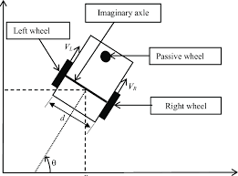**Differential Drive (DD):** The differential drive configuration (figure 2) is widely recognized as a commonly adopted and straightforward robot design. It uses a pair of wheels, independently powered on opposing sides of the robot's body. To promote stability, a non-powered third wheel can be integrated. This design boasts several benefits, including its straightforward construction, ease of control and cost efficiency. However, there are a few limitations such as traversing uneven terrains or encountering obstacles may present difficulties for this design. Moreover, the system is reliant on precise wheel movements for accurate navigation, which can be vulnerable for wheel slippage. (https://www.researchgate.net/publication/345370664_Development_of_a_Multi-Purpose_Autonomous_Differential_Drive_Mobile_Robot_for_Plant_Phenotyping_and_Soil_Sensing)

Figure : Visual representation of a DD Chassis(https://www.researchgate.net/figure/Model-of-a-differential-drive-robot_fig2_308574944)

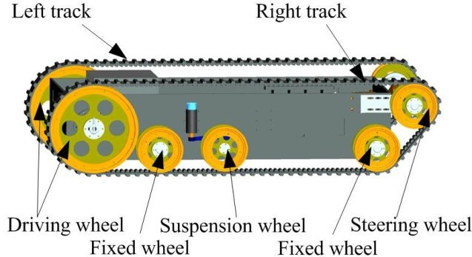 **Tracked Drive:** Tracked drive robots, use tank-like structures (figure 3), as they employ continuous tracks instead of traditional wheels. This design facilitates larger surface area contact and uniform weight distribution. Such robots excel in traversing rugged terrains like sand, mud, and gravel, thereby minimizing the risk of getting immobilized by obstacles. Nevertheless, it is important to acknowledge that the track mechanism increases the complexity and cost of construction and maintenance. Moreover, they may exhibit relatively lower efficiency and slower speed when compared to their wheeled counterparts. (https://www.science.org/doi/10.1126/scirobotics.aar7650)

Figure : Tracked Drive Implementation Example(https://www.researchgate.net/figure/Structure-of-the-tracked-mobile-robot-22-Composition-of-the-control-hardware-The-control_fig1_276184188)

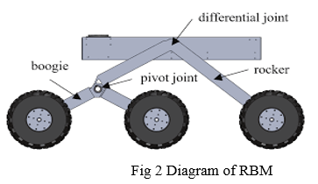**Rocker-Bogie Suspension System**: The rocker-bogie suspension system, initially designed for NASA's Mars rovers, has been adapted for terrestrial applications, including autonomous weeding robots in mountainous coffee plantations. This system, comprising rockers, bogies, and six wheels, maintains contact with the ground on uneven terrain, ensuring stability and traction (figure 4). Its enhanced mobility allows traversal of diverse terrains, as demonstrated by Mars rovers like Curiosity https://www.ijraset.com/research-paper/design-and-analysis-of-multipurpose-relief-vehicle. The system's stability is crucial for the accurate operation of onboard sensors and instruments. It also minimizes impact on crops by reducing soil compaction, crucial for agricultural applications. The passive design, devoid of complex actuators or control algorithms, simplifies the robot's design, enhancing reliability and maintainability. The Mars rovers' longevity and minimal mechanical failures testify to the system's reliability.

Figure 4: Rocker Bogie Chassis Design(https://www.ijraset.com/research-paper/design-and-analysis-of-multipurpose-relief-vehicle)

### Power Considerations

Power consideration is key as it determines operational time, with a larger power capacity enabling longer operation and increased productivity. Efficient power use reduces operational costs, and in remote areas, a well-considered power system allows longer operation between charges. Using renewable energy sources can also lessen environmental impact.

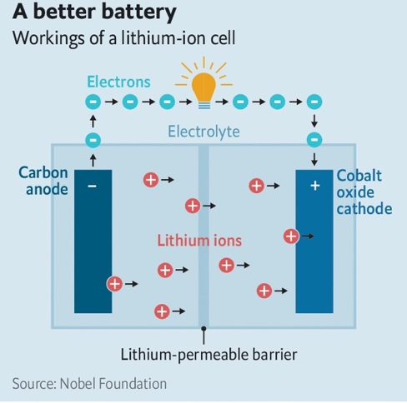

Figure : Lithium ion Inner Workings (https://www.economist.com/science-and-technology/2019/10/09/nobel-prize-for-chemistry-the-lithium-ion-battery)

**Lithium-Ion Batteries:** Lithium-ion batteries (figure 5) are widely recognized as rechargeable batteries that are popularly utilized in electronic devices due to their remarkable energy density and extended durability. Their capacity to store significant energy within a compact form factor renders them exceptionally suitable for mobile robots where size and weight are crucial considerations. Additionally, they exhibit a prolonged lifespan, allowing for numerous recharge cycles. However, they can be high in cost and require complex control systems to mitigate potential risks related to overcharging or discharging. https://www.mdpi.com/2227-9717/11/1/97

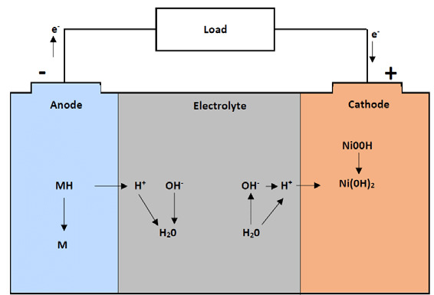 **Nickel-Metal Hydride (NiMH) Batteries:** NiMH batteries are widely acknowledged as rechargeable batteries frequently utilized in devices with high power requirements, such as robots, due to their significant capacity and energy density (Figure 6). They possess the capability to deliver large current, making them advantageous for energy-intensive robots. Moreover, they are perceived as comparatively more ecologically sound in comparison to select other battery options. However, they can exhibit a relatively higher rate of self-discharge when compared to certain alternative battery types. https://www.researchgate.net/publication/343167133_AVAILABLE_AND_FUTURE_METHODS_OF_ENERGY_STORAGE_-_WWF_POLAND_2020

Figure : Inner Workings of NiMH Battery(https://www.researchgate.net/figure/Diagram-of-NiMH-battery-operation-during-the-discharge-process-own-study_fig16_343167133)

**Solar Panels:** Solar panels convert sunlight into electricity, providing a renewable energy source for robots, particularly those operating outdoors in sunny conditions. They can reduce the need for frequent recharging or battery replacement, potentially extending the robot's operational time. However, their power generation depends on sunlight exposure and can be affected by factors like cloud cover, dust, and sun angle. They require a large surface area to generate significant power, which may be challenging for small robots. https://www.researchgate.net/publication/314069469_A_Survey_on_Solar_Cell_The_Role_of_Solar_Cell_in_Robotics_and_Robotics_Application_in_Solar_Cell_Industry

### Navigation

Navigation is critical for autonomous weeding robots in Brazil's diverse and rugged agricultural landscapes. It ensures efficient terrain traversal, accurate weed targeting, and obstacle avoidance, while enabling the robot to return to specific locations. Given the varying environmental conditions, robust navigation is essential to avoid missed weeds, crop damage, or inefficient power use, thereby ensuring the robot's overall effectiveness and efficiency.

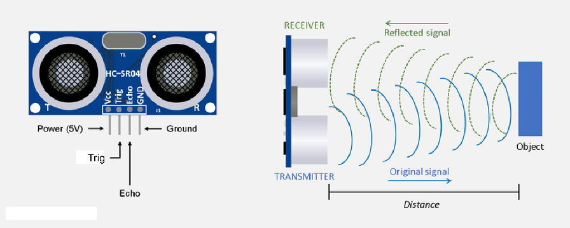**Ultrasonic detectors** measure distance by timing how long it takes for the sound they send out to return after hitting something (figure7). These detectors help guide self-moving weed removal machines on coffee farms in Brazil. They can spot many types of things, even soft ones, and are pretty cheap and simple to use. But, things like wind and temperature can mess them up. They also don't have a long range, and can have problems with things that aren't right in front of them or have tricky shapes. Even with these issues, when you use them with other detectors and guidance systems, sound-based detectors can help make a good navigation system (http://campus.murraystate.edu/academic/faculty/gbunget/EGR390/Distance_Measurements/Distance_Meas.htm)

Figure : Ultrasonic Detector Explained (http://campus.murraystate.edu/academic/faculty/gbunget/EGR390/Distance_Measurements/Distance_Meas.htm)

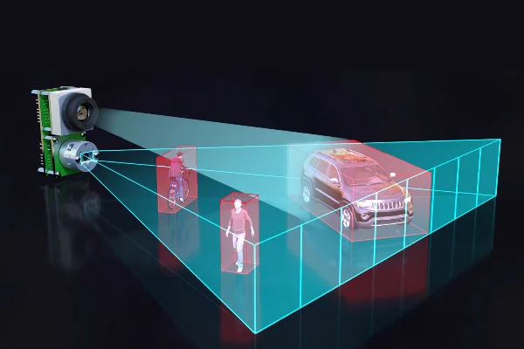**LIDAR, short for Light Detection and Ranging,** serves as a key tool for self-moving weed-removal bots working in hilly coffee farms, as it can create detailed 3D maps useful for moving around, spotting obstacles, and charting out the land (figure 8). The way it works is by shooting out lasers and then timing how long the light takes to return, building a 3D model of the surroundings in the process. The highly detailed information LIDAR provides is vital for getting around tricky landscapes, and the ability to map out the area in real-time allows for quick changes in response to shifts in the environment. But, top-quality LIDAR detectors can be expensive and use a lot of power. Mixing LIDAR with other detectors can make navigation even better, though it could make the system more complicated. However, the latest tech developments may lead to cheaper and more energy-friendly solutions (https://www.allaboutcircuits.com/news/solid-state-LiDAR-is-coming-to-an-autonomous-vehicle-near-you/)

Figure : LIDAR Capability (https://www.allaboutcircuits.com/news/solid-state-LiDAR-is-coming-to-an-autonomous-vehicle-near-you/)

### Image Processing And AI/ML

Image Processing and artificial intelligence/machine learning (AI/ML) methodologies are critical subsystems in the operational architecture of autonomous weeding robots. These technologies facilitate crucial operations such as weed-crop discrimination, optimization of weed extermination processes, and amplification of total system efficiency. This section delves into the functionality of visual data interpretation and AI/ML in the context of automated weeding robotics, supplemented by industry-specific examples illustrating their practical application.

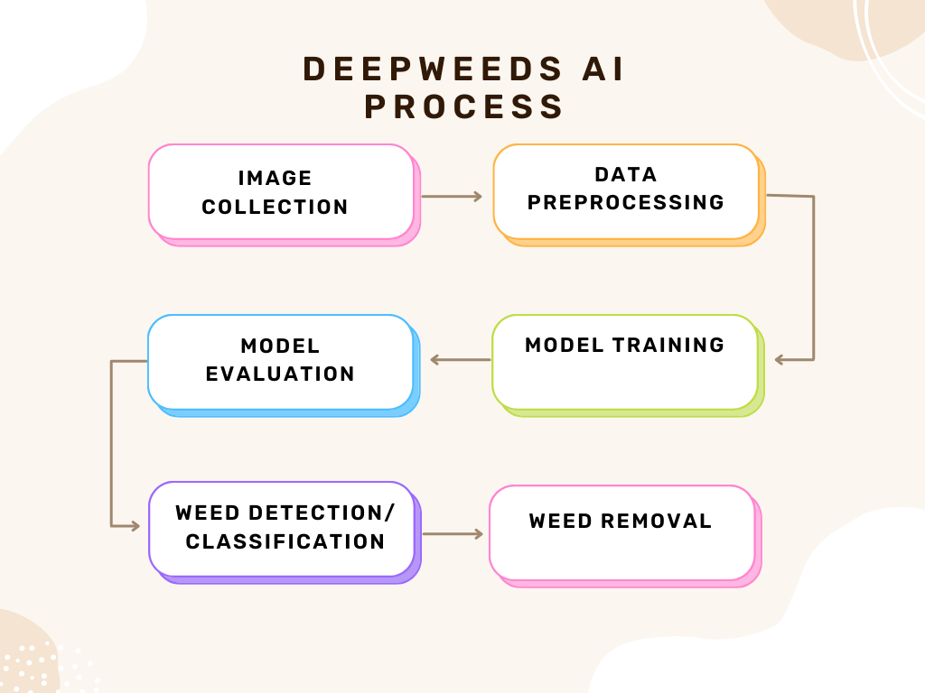

Figure 9 - AI Process Schematic (Self-Generated)

According to Figure 9, the steps involved within the AI model are as follows:

1. **Image Collection**: Multispectral cameras mounted on the weed killer can capture images of the farmland. Preferably with typical features of weeds and local crops.
2. **Data Pre-processing**: The captured images are pre-processed to allow them to be recognised by the machine. The process includes unifying image attributes, dimensions etc.
3. **Feature Extraction**: In DeepWeed AI recognition system, using images of farmland that have been processed to achieve feature recognition and enrich the database. Different feature of weeds and crops are extracted from the images, including colour, texture etc.
4. **Model Training**: A deep learning model (e.g. a convolutional neural network) is trained on the pre-processed images and this allows the model to continuously learn to distinguish between images of weeds and crops based on the patterns it recognizes within the training data.
5. **Model Evaluation**: The trained model is evaluated on a separate set of images called “the test set” to measure its performance and accuracy. This step helps to ensure that the model is able to generalize its predictions to new and unseen data thus improving its effectiveness.
6. **Weed Detection**: The trained model is used in the field (either on a computer or on a robot) to detect weeds in the new images that are captured. Subsequently, the model analyzes each image and makes a prediction about whether it contains a weed or a crop.
7. **Weed vs Crop Classification**: In this step, the system distinguishes between weeds and crops based on the predictions made by the model. If the model predicts that an image contains a weed, the system classifies it as a weed; if the model predicts that an image contains a crop, the system classifies it as a crop.
8. **Weed Removal**: Once the weeds are detected and classified, a mechanism (like a robotic arm or a laser) is used to remove the weeds. The robot navigates to the location of each detected weed and performs the removal operation.

### Industry Examples

Based on existing research, it appears that image recognition technology and AI/ML technology are feasible for application in agricultural production and weed monitoring. And in recent years it has also attracted the attention of research institutes and technology companies.

* **Blue River Technology's See & Spray:** They have developed a system called See & Spray. This setup involves cameras on tractors capturing images, which are the analysed to separate weeds from crops. The system then precisely sprays herbicides, but only on the weeds. A noteworthy benefit of this technology is it’s capacity to reduce herbicide use by a massive 90% compared to conventional methods. https://bluerivertechnology.com/ourmethods/
* **Ecorobotix's ARA:** As mentioned earlier Ecoroboti, which has developed a solar-powered robot named ARA. This robot uses AI and computer vision to spot and pinpoint weeds. Once identified, a diode laser is used to target the weeds. The robot uses machine learning algorithms to continually enhance its weed detection and classification accuracy. https://ecorobotix.com/en/ara/
* **DeepWeeds:** This is a research project based in Australia that’s working on a weed detection system using deep learning specifically for Australian agriculture. This project has made a dataset of labelled weed images available to the public. And they’re developed a convolutional neural network (CNN) model that’s highly effective at weed classification. https://github.com/AlexOlsen/DeepWeeds

## Market Research:

### Brazil

The South American continent spans from the temperate tropics near the equator to the rugged, wind-swept landscapes of Patagonia in the south, encompassing a diverse range of climates, ecosystems, and cultures along its breadth. Such geographical diversity allows for the growth and cultivation of many different crops. Lying on the continent’s eastern reaches is Brazil - a country home to approximately 214.3 million people and the fourth largest food producer in the world after China, India, and the United States [3], [4]. The nation boasts a GDP of over 1.6 trillion USD [3], with crop and livestock production accounting for up to 8% of this [5]. Annual crop production area in Brazil spans an expansive 69 million hectares [6]. Among the various crops cultivated, soybeans, maize, sugarcane, and rice are all grown at a vast commercial level, collectively accounting for up to 90% of the total crop area. It is noted that soybeans alone occupy half of this cultivated land [6]. However, Brazil is most renowned for its coffee industry, whereby it cultivates significantly more than any other country, firmly positioning it as the world's leading producer [7]. The majority of this sector exists within the South-Eastern States of Minas Gerais (59%), Espirito Santo (19%), and Sao Paulo (9%), with Figure providing a geographical breakdown this. Located between the Equator and the Tropic of Capricorn, this region possesses a warm, tropical, and humid climate, making it suitable for coffee cultivation.

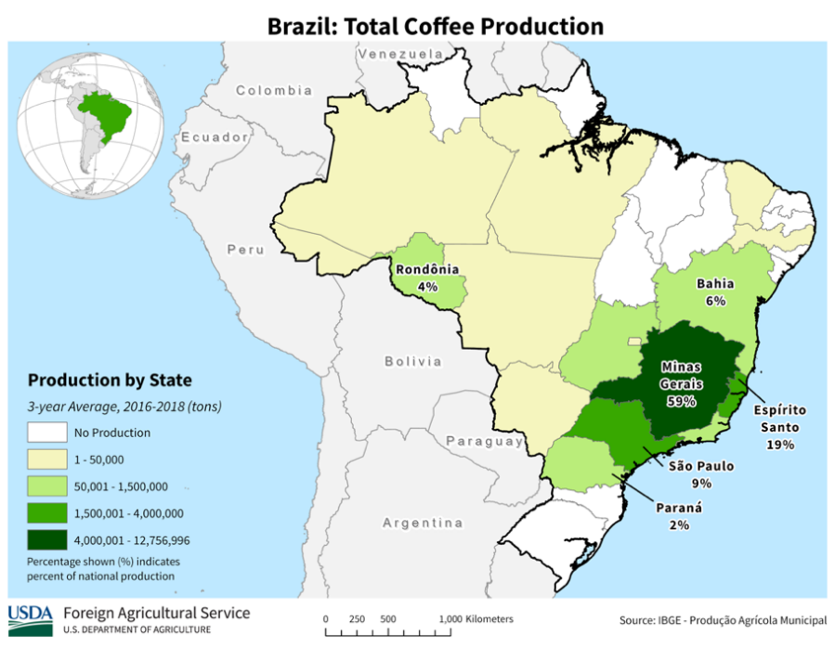

Figure 10 - Geographic Breakdown of Brazilian Coffee Production by Region [8]

According to ….. Robusta coffee bushes prefer lower altitudes (0ft – 2500ft) at temperatures ranging from 22°C to 25°C, while Arabica grows better at higher altitudes (2000ft – 6500ft) in slightly lower temperatures between 19°C and 22°C [9], [Appendix]. Temperatures within these districts typically average around 29°C, meaning coffee cannot be cultivated year-round [10]. Annual precipitation levels reach approximately 103.45mm [11]. Additionally, the high altitudes (600m - 1800m [12]) combined with the volcanic, nutrient dense, and slightly acidic soil seen within these states creates optimal conditions for the bushes to mature at a slow and steady rate [13]. Coffee thrives in well-drained soils. It is therefore grown on hillsides and slopes with the purpose of providing better drainage to avoid water logging and achieve even water distribution [14]. Bushes mature optimally with moderate levels of sun exposure (around 1800 hours of sunshine annually) [15]. Figure maps the levels of direct solar irradiation across the country, illustrating the optimal regions for healthy coffee bush development.

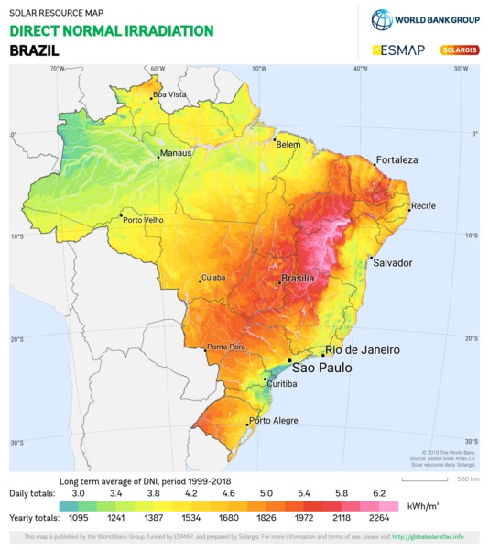

Figure 11 - Geographic Breakdown of Direct Normal Irradiation in Brazil [16]

### Weeds

Weeds, if left unchecked on a coffee plantation can reduce yields by up to 30% - 40% as revealed in an interview with …., a coffee consultant in Brazil’s … region [Appendix]. They compete with crops for sunlight, water, and nutrients, while also serving as alternative hosts to pests and diseases, allowing them to proliferate and eventually spread to the bushes, often causing further damage [Appendix]. Common weed species often found in Brazilian (and likely South American) agriculture as well as their infestation period and cycle life can be seen below in Table.

Table 3 - Breakdown of Weeds Commonly Seen on Brazilian Coffee Plantations [17]

|  |  |  |
| --- | --- | --- |
| **Common Name:** | **Infestation Period:** | **Cycle:** |
| Dayflower | Dry and Rainy | Perennial |
| Nutsedge | Dry and Rainy | Perennial |
| Brazilian Satintail | Dry and Rainy | Perennial |
| Sourgrass | Dry and Rainy | Perennial |
| Pigweed | Dry and Rainy | Annual |
| Morningglory | Dry and Rainy | Annual |
| Buttonweed | Dry and Rainy | Annual |
| Marigold | Dry and Rainy | Annual |
| Sowthistle | Dry | Annual |
| Tasselflower | Dry | Annual |
| Jamaican Crabgrass | Rainy | Annual |
| Goosegrass | Rainy | Annual |

### Weed Management

Several effective approaches may be employed to successful mitigate the impact of weeds and thwart their growth. Cultural management involves planting rows at least 40cm - 50cm apart and cultivating the area between the bushes with Congo and Signal Grass [18]. This variant of grass has a minimal impact on the crop, and once cut, will shade out any potential spots under or near the bush stems, stopping the growth of any future weeds. This tactic was highlighted in an interview with… [Appendix] whereby farmers often employ row shading as an effective weed control method. This approach is cost-effective, low-maintenance, and easy to implement. Soil solarisation is another preventative method that is often employed. It entails placing layers of clear plastic over unused soil, thereby elevating the soil temperature to levels fatal to many weeds, stopping growth at an early stage and effectively controlling spread [19].

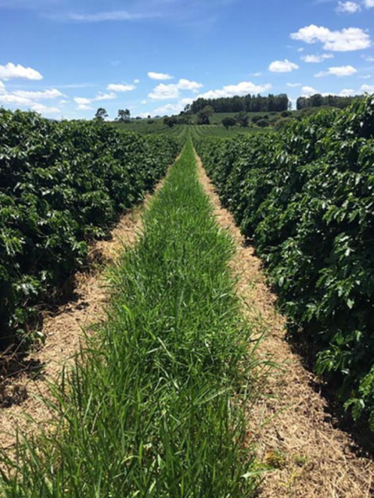

Figure 12 - Consortium of Congo Grass with Coffee [17]

Biological control approaches make use of an agent that keeps the weed population at lower levels than would naturally occur, without causing any economic harm to the crops. Ruminant animals such as sheep or birds may be used to feed on the weeds, however, this method rarely ever practised in Brazil as more research is required to prove its viability [18]. Mechanical control, or otherwise known as manual weeding, is a slow and laborious process that involves the physical removal of weeds through different techniques and is one of the most popular methods currently being implemented on coffee plantations. Depending on the size of the farm, slope index, and spacing between rows, these would typically include using a grazer, brush, or hands to manually remove the weeds [18]. Lastly, the most frequently employed method of weed control in Brazil is the chemical approach, which entails the use of herbicides. When seeking to maximise their effectiveness and minimise their environmental impact, a farmer must select the appropriate herbicide according to several factors such as the weed infestation level, crop phase, soil type, toxicology, cost, and the skill level of the farm workers [18]. The use of such chemicals does however increase the risk of creating herbicide-resistant weeds and unwanted environmental contamination, while also creating Glyphosate residue issues as highlighted by … [Appendix]. Brazil is one of the largest importers of herbicides, and in 2018, used more than 60,000 tonnes of highly hazardous chemical, most of which are banned in Europe [20]. These are mostly imported from Russia, China, and Belarus, while only around 25% is produced locally [21]. The most common herbicides currently used in Brazil as well as their application time, active ingredient, and dose per hectare of land may be seen below in Table.

Table 4 - Main Herbicides Recommended for Coffee Plantations

|  |  |  |  |
| --- | --- | --- | --- |
| **Commercial Name:** | **Active Ingredient:** | **Application Time:** | **Dose/ Hectare:** |
| Round Up Original | Glyphosate | POST | 3.0–5.0 L |
| Sencor | Metribuzin | PRE | 1.0–2.0 L |
| Finale | Glufosinate-ammonium | POST | 2.0–3.0 L |
| Goal and Galigan | Oxyfluorfen | PRE | 2.0–6.0 L |
| Alion | Indaziflam | PRE | 0.15–0.20 L |
| Flumyzin 500 | Flumioxazin | PRE and POST | 0.05-0.240 L |
| Heat | Saflufenacil | POST | 35–100 g |

Additional herbicides include Atrazine, which exhibits low toxicity, and Paraquat, noted for its high toxicity and being prohibited in over 30 countries due to its health risks [19], . As of now, Brazil employs a combination of techniques to manage weed growth, which include manual weeding, successive mowing, the use of herbicides, and shading [Appendix].

### Existing Products

The demand for coffee is expected to undergo a compound annual growth of 11.3% from 2023 to 2030, thereby placing more pressure on farmers to meet this heightened level of demand [23]. Moreover, the occurrence of major climactic events, such as droughts and forest fires, has also increased in frequency [24]. Given that more than 90% of Brazil's agriculture relies on rainfall, these changes present a formidable challenge to maintaining consistent crop yields [25]. To aid farmers in delivering their future quotas, technology has been introduced onto farms to improve and maximise their harvests. Existing products include: The AVO by Ecorobotix is a lightweight (130kg), GPS driven, solar powered tank-type robot capable of operating autonomously to target and spray weeds through the use of a complex camera system [26]. The company claims to be able to treat up to 10 hectares of land per day, while using 95% less herbicide. AVO uses a targeted spraying agent to eradicate weeds, with the project still in its Beta testing phase. The company also plans on designing and developing a fleet of low-flying drones to gather information on the area to be weeded, thus optimising the process. LASERWEEDER by Carbon Robotics is roughly the size of a car and attached to the back end of a tractor [27]. A high powered 150W precision laser, capable of firing every 50 milliseconds targets weeds at the meristem, in turn killing, or severely stunting their growth. Powerful bed top lighting makes weeding possible in all conditions. The system combines deep learning algorithms with Nvidia’s powerful GPU hardware and camera to identify and exterminate weeds. Naio Technologies offers a range of weeding solutions including Ted, Jo, Oz, and Orio, with the former two catered towards vineyards, and the latter two to commercial farming [28]. All systems rely on precise GPS navigation and a range of mechanical tools to remove weeds. They are all capable of offering additional assistance such as hoeing, seeding, furrowing, and transporting produce during harvests. Dandy is a compact robot specifically designed to eradicate lawn weeds on plots up to one acre in size [29]. By combining AI with an advanced camera system, Dandy identifies unwanted growths, applying a localised spray of herbicide to selected spots. This approach, although still relying of chemicals, significantly reduces the amounts used (Up to 90%), thus increasing efficiency and reducing costs for the farmer. Its navigation system comprises of GPS and an object detecting camera.

### First Hand Market Research

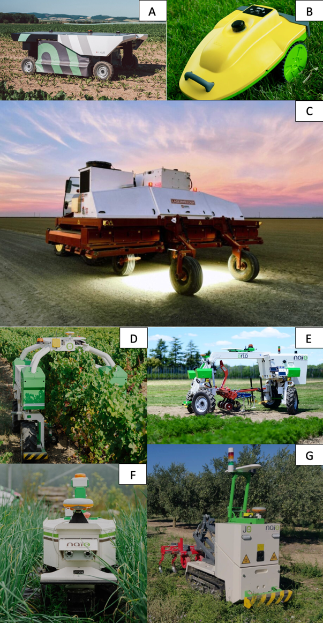In conducting first-hand research, Brazilian coffee farmers and consultants were approached with various questions regarding the state of the nation’s coffee industry. These were (name and from where). The information gathered sought to provide a clearer picture of the current challenges, practices, and opportunities within Brazil's coffee plantations. This information is vital in identifying potential areas for improvement and formulating strategies that can bolster the market’s resilience and productivity. The consensus was that an autonomous weeding robot would in fact be desired by farmers, provided it is affordable and effective [Appendices 1, 2, and 3]. It was noted that size of coffee plantations varies significantly: small-hold farms typically span less than 10 hectares, medium-sized ones cover between 20 to 100 hectares, while large-scale plantations extend from 100 to 1,000 hectares [Appendix 2]. Both…. (Name) indicated that while the majority of farms have access to electricity, some rural regions of the country may find access challenging, therefore forcing a reliance on alternative sources, such as solar power. When it comes to purchasing power, it was pointed out that producers often prefer to purchase their equipment outright as a pose to renting it [Appendix]. The industry currently has little to no laws regulating the use of autonomous robots on farms. The use of aerial equipment and unregistered herbicides is however subject to stringent guidelines [Appendix].

## Cultural, Societal, Diversity & Inclusion Factors:

As we venture into the future of agriculture with the introduction of autonomous weeding robots, it's crucial to remember the human element. This is particularly important in places like Brazil's mountainous coffee plantations, where the integration of such technology needs to be handled with sensitivity. Let's delve into the various factors that need to be considered to ensure these advanced technologies are embraced by the coffee farming communities.

### 

### Cultural Factors

**• Respecting traditional farming methods**: Many coffee-growing communities in Brazil have a cherished heritage of farming practices that have been passed down through generations. For instance, handpicking coffee cherries is a time-honored tradition in many of these plantations. The introduction of autonomous weeding robots could disrupt these customs, requiring farmers to adapt to new ways. Therefore, it's essential to engage with these communities, understand their traditions, and respect their values. This approach will ensure that the new technology is introduced in a manner that is respectful and supportive.

• **Language and communication:** Not everyone is fluent in technical jargon. To ensure the successful adoption of autonomous weeding robots, we need to communicate effectively with farmers and other stakeholders in the coffee industry. This means providing user manuals, training materials, and support in local languages. Companies like Blue River Technology are already setting a good example with their See & Spray technology.

### Societal Factors

**• Employment and labor:** While autonomous weeding robots could increase efficiency and reduce labor costs, they could also lead to job losses for farmworkers. This is a significant concern, as many workers depend on these jobs for their livelihood. It's important to address these concerns directly and explore opportunities for retraining workers. For instance, they could be trained in new roles related to the maintenance, operation, and management of the robots. Companies like John Deere are leading the way in this regard.

**• Education and training**: The introduction of autonomous weeding robots means farmers and workers will need to learn new skills. Tailored education and training programs can help bridge this skill gap. The DeepWeeds project in Australia is a great example of this, providing local farmers with the training they need to use their deep learning-based weed detection system.

### Diversity and Inclusion Factors

**• Gender equality:** It's important to ensure that the benefits of new technology are accessible to all. This means making sure that both men and women have equal access to education, training, and opportunities related to the technology. In Rwanda, for example, the introduction of drones for crop monitoring included training programs specifically designed for women.

**• Accessibility for people with disabilities:** Everyone should have the chance to benefit from new technology. This means designing autonomous weeding robots and associated tools that are accessible to people with disabilities. Companies like Liftware are leading the way in creating assistive technologies, showing us that it's possible to create a more inclusive environment in the coffee farming industry.

## Environmental Sustainability of Product Sector:

In recent years, environmental sustainability has emerged as a top priority, particularly in the agricultural sector, where the effects of climate change and environmental degradation are felt most acutely. Autonomous weed-removal devices from Activelio AgriTech offer a novel approach to vegetation management that could significantly reduce the environmental impact of agricultural operations. The objective of this analysis is to critically evaluate the environmental sustainability of this product sector.

**Energy Efficiency**

Environmental sustainability is primarily concerned with energy efficiency in all robotic applications. In contrast to conventional gas-powered farm equipment, autonomous weed-removal devices typically operate on renewable electric power. However, the energy efficiency of these robots can differ significantly depending on their design, operating conditions, and the efficiency of their power conversion and storage systems. It is necessary to investigate the precise power requirements and consumption patterns of these devices in order to comprehend their energy footprint in its entirety [30], [31].

**Waste Reduction**

Autonomous weed-removal devices offer a significant advantage for waste reduction. Traditional techniques for controlling vegetation, such as chemical herbicides, generate a substantial amount of waste and have a substantial impact on the environment. Autonomous weed-removal devices, in contrast, physically remove vegetation, reducing the need for chemical interventions and, consequently, waste production and environmental contamination. This reduction in pollution can be measured by comparing the quantity of herbicide typically used in a given area to the amount of vegetation removed by a robot [32].

**Utilisation of eco-friendly materials**

The environmental sustainability of a product also depends on the construction materials employed. Using eco-friendly materials, such as biodegradable plastics or recycled metals, can significantly lessen a product's environmental impact. However, these materials must also meet the durability and performance requirements of the application. Consequently, the selection of construction materials for autonomous weed-removal devices is an essential aspect of their environmental sustainability. It is essential to consider the entire lifecycle of these materials, from extraction and processing to disposal or recycling at the conclusion of their useful existence [33].

**Impact Potential on Biodiversity**

Regarding the environmental sustainability of autonomous weed-removal devices, consideration must also be given to their potential impact on biodiversity. It is well-established that excessive chemical herbicide use can harm non-target species and disrupt ecosystems. Autonomous weed-removal robots have the potential to reduce this impact by selectively removing vegetation, but their effect on non-target species must also be carefully evaluated. The effect of these devices on the structure and composition of the soil, as well as the microorganisms that inhabit the soil, could have significant ecological consequences [34].

# **Design:**

## Description of design process and evaluation criteria identified:

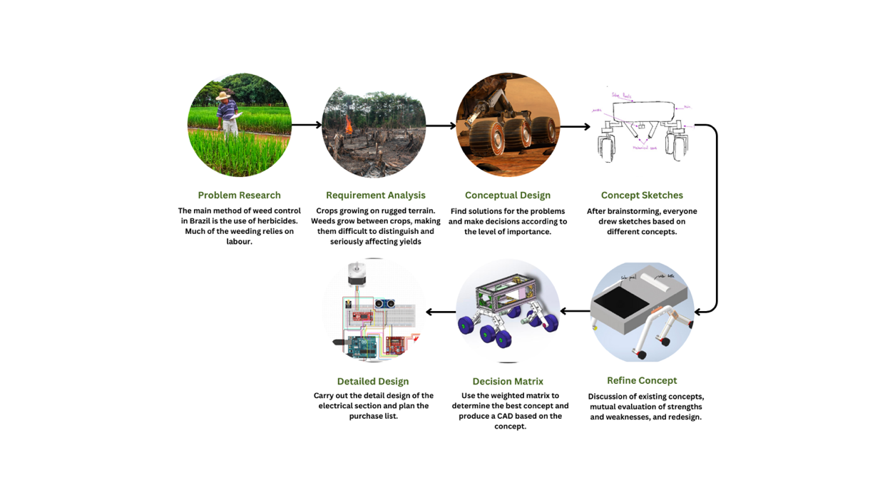

Figure 13 - Design Process

The design process for our autonomous weed-removal robot incorporated a structured design procedure to address the challenges posed by South America's severe and unforgiving agricultural terrain. Understanding the problem's context, identifying critical performance parameters, and developing and refining potential solutions were the initial steps in the process.

Our design process began with problem analysis, as demonstrated in the aforementioned report section. Indeed, the investigation revealed the prevalent weed management techniques in Brazil, which rely heavily on pesticides and manual labour. The research uncovered a critical deficiency in the existing methods: there was an urgent need for an automated, environmentally sustainable solution that would not only reduce the reliance on labour but also mitigate the environmental impact of pesticides.

Following the problem analysis was the phase of requirement analysis. It began with the identification and establishment of the robot's main performance parameters, which were divided into two primary categories: hard requirements and soft requirements.

The hard requirements refer to the non-negotiable parameters essential for the robot to perform its primary functions. Failing to meet these requirements would deem the robot ineffective for its intended use. The hard requirements ensured that the robot could remove and identify weed, navigate autonomously, provide adequate traction and durability, have an effective power system, be simple to maintain and repair, adhere to safety standards, and remain affordable to end users.

Soft requirements, on the other hand, denote non-mandatory parameters that were extremely desirable for enhancing functionality and end-user experience. They are intended to provide consumers with additional value. Our soft requirements included soil monitoring and treatment, an alert system for farmers, and a transport and disposal system for vegetation after their removal.

In our endeavor to satisfy these requirements, our team generated five unique conceptual designs, followed by conceptual sketches and refined designs. Each design integrated a unique set of technologies and mechanisms to meet the predefined specifications.

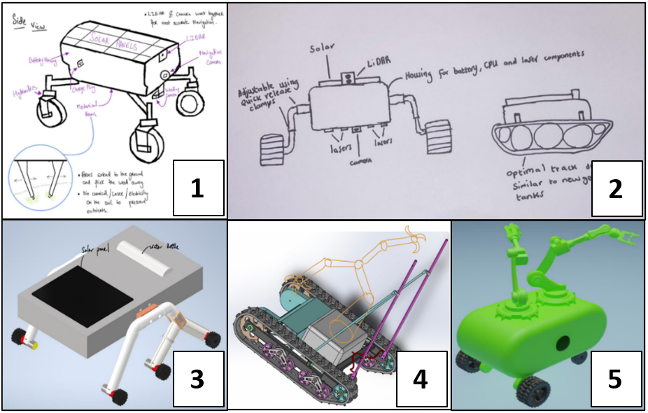

Figure 14 - Five Initial Conceptual Designs

Design 1 utilized LIDAR sensors and cameras for navigation, and a mechanical arm for weed removal. This design prioritized accuracy in both navigation and weed removal. However, it lacked the robust mobility solution required for the variable terrains of the Brazilian crop fields.

Design 2 incorporated the same navigation system as Design 1, but tank treads for traction and maneuverability, and a laser system for weed removal were added. Compared to Design 1, the tank treads provided superior traction on rocky terrains. However, the tracks were prone to mechanical failure and required routine maintenance, so they did not meet the requirement of being simple to maintain. Design 4 utilized tank treads for locomotion, similar to Design 2, but reintroduced the mechanical arm for weed removal. Although the mechanical arm provided the capability to physically remove and collect weed, its larger damage zone and increased complexity increased the likelihood of damaging adjacent crops, mechanical issues, and maintenance requirements, respectively.

Design 5 utilized a mechanical arm for weed removal, comparable to Design 1. However, it was distinguished by a sophisticated soil monitoring system that could provide producers with valuable data. Even though these additional features satisfied the soft requirements, Design 5 lacked the sophisticated mobility and weed identification features of the other designs.

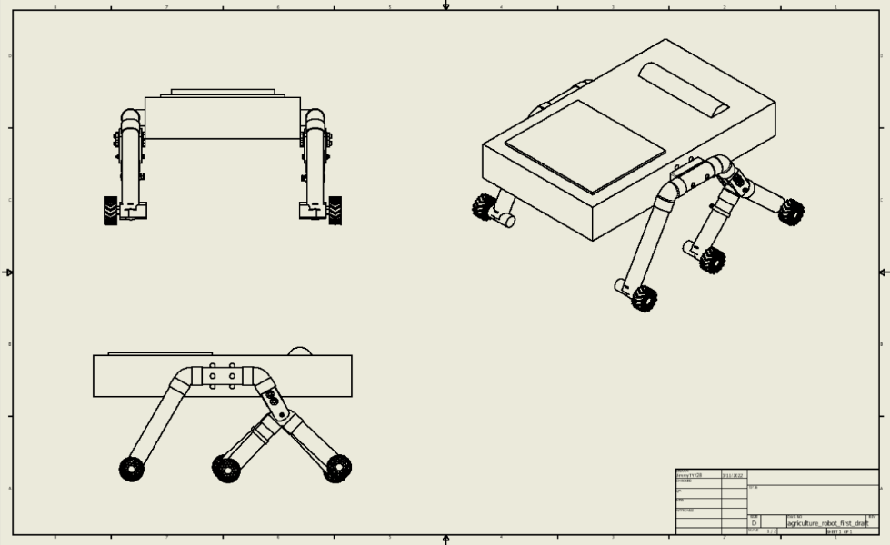

Figure 15 - Concept Design 3

In contrast, Design 3 distinguished itself with a balanced approach to all requirements. It utilized a 6-wheeled Rocker Bogie system for traction and maneuverability, a suspension wheel design utilized by NASA's Mars rovers [35]. This system ensured that the robot's functionality was consistent despite the variable terrain conditions in the Brazilian coffee fields. In addition, the design's high ground clearance prevented getting trapped and provided stability on irregular terrain, making it more reliable than the tank treads used in Designs 2 and 4.

Using a combination of LIDAR and high-resolution cameras, Design 3 utilized the same navigation and weed identification system as previous designs. However, what distinguished Design 3 was the addition of machine learning algorithms, which improved the camera's ability to accurately differentiate between weed and crops. Design 3 utilized an innovative laser system for weed eradication, in accordance with our strict requirement for environmental consciousness. The laser system could disrupt weed growth without physical contact, eliminating the need for chemical herbicides and reducing the environmental impact. This combination of technologies assured precise weed removal while minimizing crop damage, giving it an advantage over the mechanical arm utilized in Designs 1, 4, and 5.

Moreover, components of the Design 3 were individually replaceable, allowing for simple maintenance and repair and minimizing idleness and repair costs for Brazilian farmers. This element of design offered a significant advantage over other designs, whose more intricate mechanical systems could result in longer repair times and higher overall costs.

Table 5 - Weighted Decision Matrix

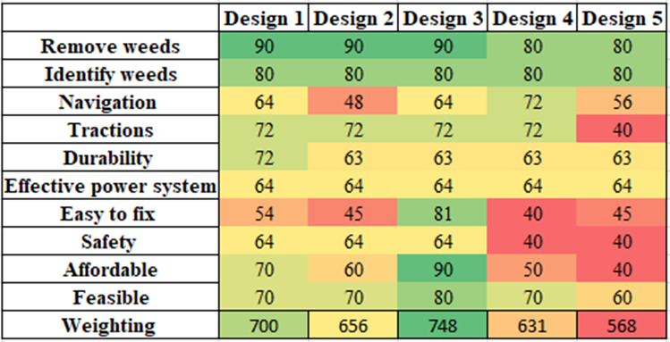

Moreover, the superior performance of Design 3 in the weighted decision matrix analysis was incontrovertible, as shown in table x. However, our team identified opportunities for improvement by incorporating the distinguishing characteristics of alternative designs. This resulted in the final robot design, which surpasses all others in meeting all hard requirements and the majority of emotional requirements. This achievement represents a significant milestone in our pursuit of an effective and environmentally favorable weed removal solution for coffee crop fields in Brazil.

Table 6 - Final Design’s Solutions to Hard Requirements

|  |  |
| --- | --- |
| **Requirements** | **Solutions** |
| Remove weeds | Lasers |
| Identifying weeds | Camera |
| Navigation | Lidar/ camera/ pre route (GPS) |
| Traction | 6 wheels Rocker Bogie |
| Durability | Metal frame |
| Effective power | Battery |
| System easy to fix | PVC pipes |
| Safety | Laser/mechanical arms below robot |
| Affordability | PVC pipes |
| Feasibility | Blades and chassis system |

## Design informed by market analysis:

To ensure Ray-Zer’s design aligns with current industry trends, market demands, and future projections, the team has conducted an in-depth market analysis. This exploration of market dynamics has not only informed design choices but also provided a robust understanding of the ecosystem within which our product will operate. The following details illustrate how certain design aspects of the rover were influenced by various market insights.

Rocker-Bogie: From the outset, the design team was aware of the significant challenge posed by Brazil’s rugged and unforgiving terrain, particularly that of plantations where coffee in grown. To accommodate for this, a Rocker-Bogie design has been implemented. This chassis possesses an articulated suspension system, meaning the wheels can move freely in relation to the rest of the body, allowing the rover to adapt and conform to the shape of the surface beneath it, ensuring steady operation. Furthermore, traction and stability are improved through the system’s differential linkage, allowing weight to be distributed evenly across all six wheels. This design choice negates the need for a complex system of springs and dampers, simplifying construction and reducing costs while decreasing the risk of it tipping over. This is further improved by the vehicles low centre of gravity.

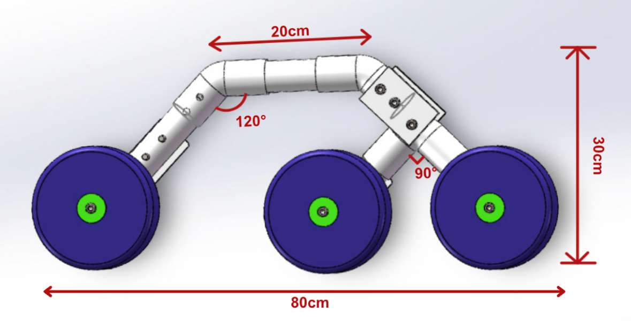

Figure 16 - Rocker-Bogie Assembly CAD

Laser: Laser technology is distinguished for its non-invasive approach to weed control. It therefore does not cause any form of soil erosion and disturbance as seen with mechanical removal techniques. With a high degree of precision, less than ± 1 mm [36], the laser selectively targets the weed's meristem, limiting any potential disturbance to the surrounding ecosystem. This serves to protect delicate eco-system consisting of vital organisms and fauna that significantly contribute to the health of the soil, thus aligning with the environmental sustainability commitments of Activelio. Brazil’s limited regulatory guidance in the space has supported this choice. Moreover, this method of eradication completely eliminates the threat of weeds developing any form of resistance, a significant worry highlighted in the market research [Appendix].

3D Printed Parts, PVC Piping, and T-Slot Bars: Emphasising the affordability for farmers in developing countries, as well as the accessibility, reliability, and ease of repairing components, the design team selected PVC piping and Aluminium T slot bars as the materials of choice. These choices present a cost-effective option when compared to other, highly technical, precision manufactured approaches. Furthermore, 3D-printed polymers have been adopted as pose to traditional metal alloys for the manufacture of key components such as motor brackets. This material transition not only brings substantial cost savings but also aligns with a more sustainable production approach. Designs may subsequently be sent to an in-house manufacturing studio in Brazil, and shipped locally when required, reducing dependence on international shipping. This was essential as considering economic trends and projections, it was crucial that the design remain affordable and provide excellent value for money. Additionally, given the abundance of both PVC and aluminium, farmers in remote locations can easily and rapidly repair their Ray-Zer units without relying on specialist knowledge, tooling, or external supply chains, thus ensuring minimal downtime. Furthermore, PVC piping brings an aspect of modularity to the design, allowing farmers to modify Ray-Zer’s height for use on different crops and thus catering towards the increased interest in customization and versatility in the market.

Solar Panel: In order to maximize Ray-Zer's operational time, a solar panel has been incorporated into the design to act as a secondary source of power. The photovoltaic power potential map illustrated in Figure underscores the substantial solar energy available in Brazil for harnessing, thus making this additional energy source an apt choice for the vehicle. This integration not only optimizes the power efficiency but also supports the drive towards sustainable and renewable energy use. This was a key factor highlighted in the first-hand research conducted with industry specialists.

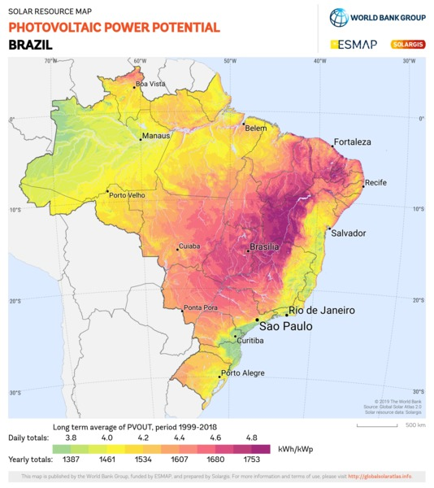

Figure 17 - Map Depicting Photovoltaic Power Potential Across Brazil [37]

Nutrient Distributing System: In conducting thorough market research, the design team closely examined existing products offered by industry leaders like Naio, whose solutions extend beyond basic weeding to additional farming tasks such as hoeing, seeding, and furrowing. This analysis offered insights into the evolving expectations of modern farming equipment. In response to these emerging industry trends, the design team decided to integrate a nutrient distributing system into Ray-Zer’s side profile, allowing farmers to distribute precise amounts of necessary nutrients across their fields, thereby optimizing their use of resources and potentially increasing their crop's productivity.

FEA Optimisation: Component geometries were optimised based off findings from in depth FEA analysis. Cross sections were made smaller, and wall thicknesses reduced in parts of the chassis assembly. Materials that were to be manufactured from metal alloys underwent changes to 3D printed polymers, leading to a significant reduction in system mass and cost. This was crucial in order for the design to be able to efficiency navigate over waterlogged and muddy fields, as is often the case for agricultural land situation near the Amazon River basin. This analysis also played a key role in ensuring the design was robust and reliable.

## Detailed CAD and Electronics Design:

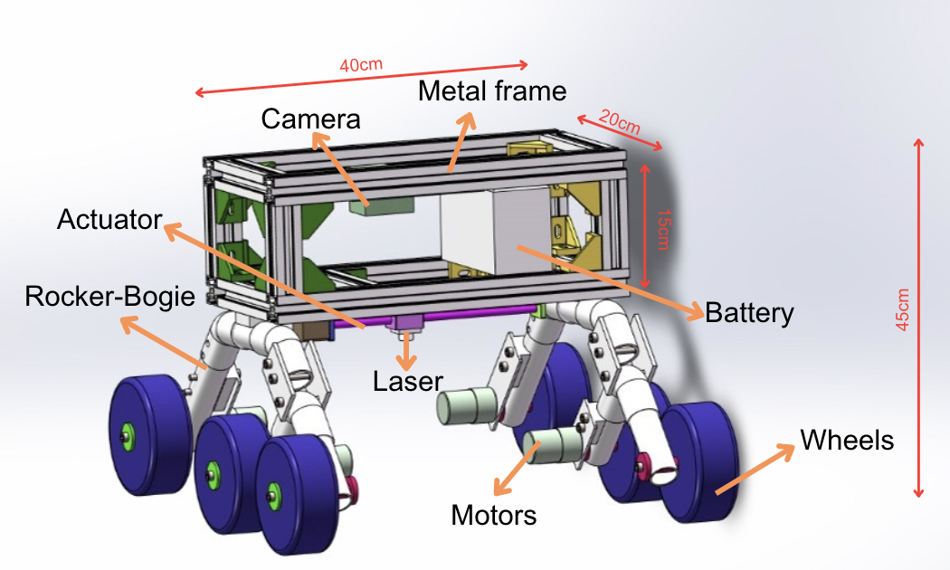

Figure 18 - Detailed and Labelled CAD of Ray-Zer

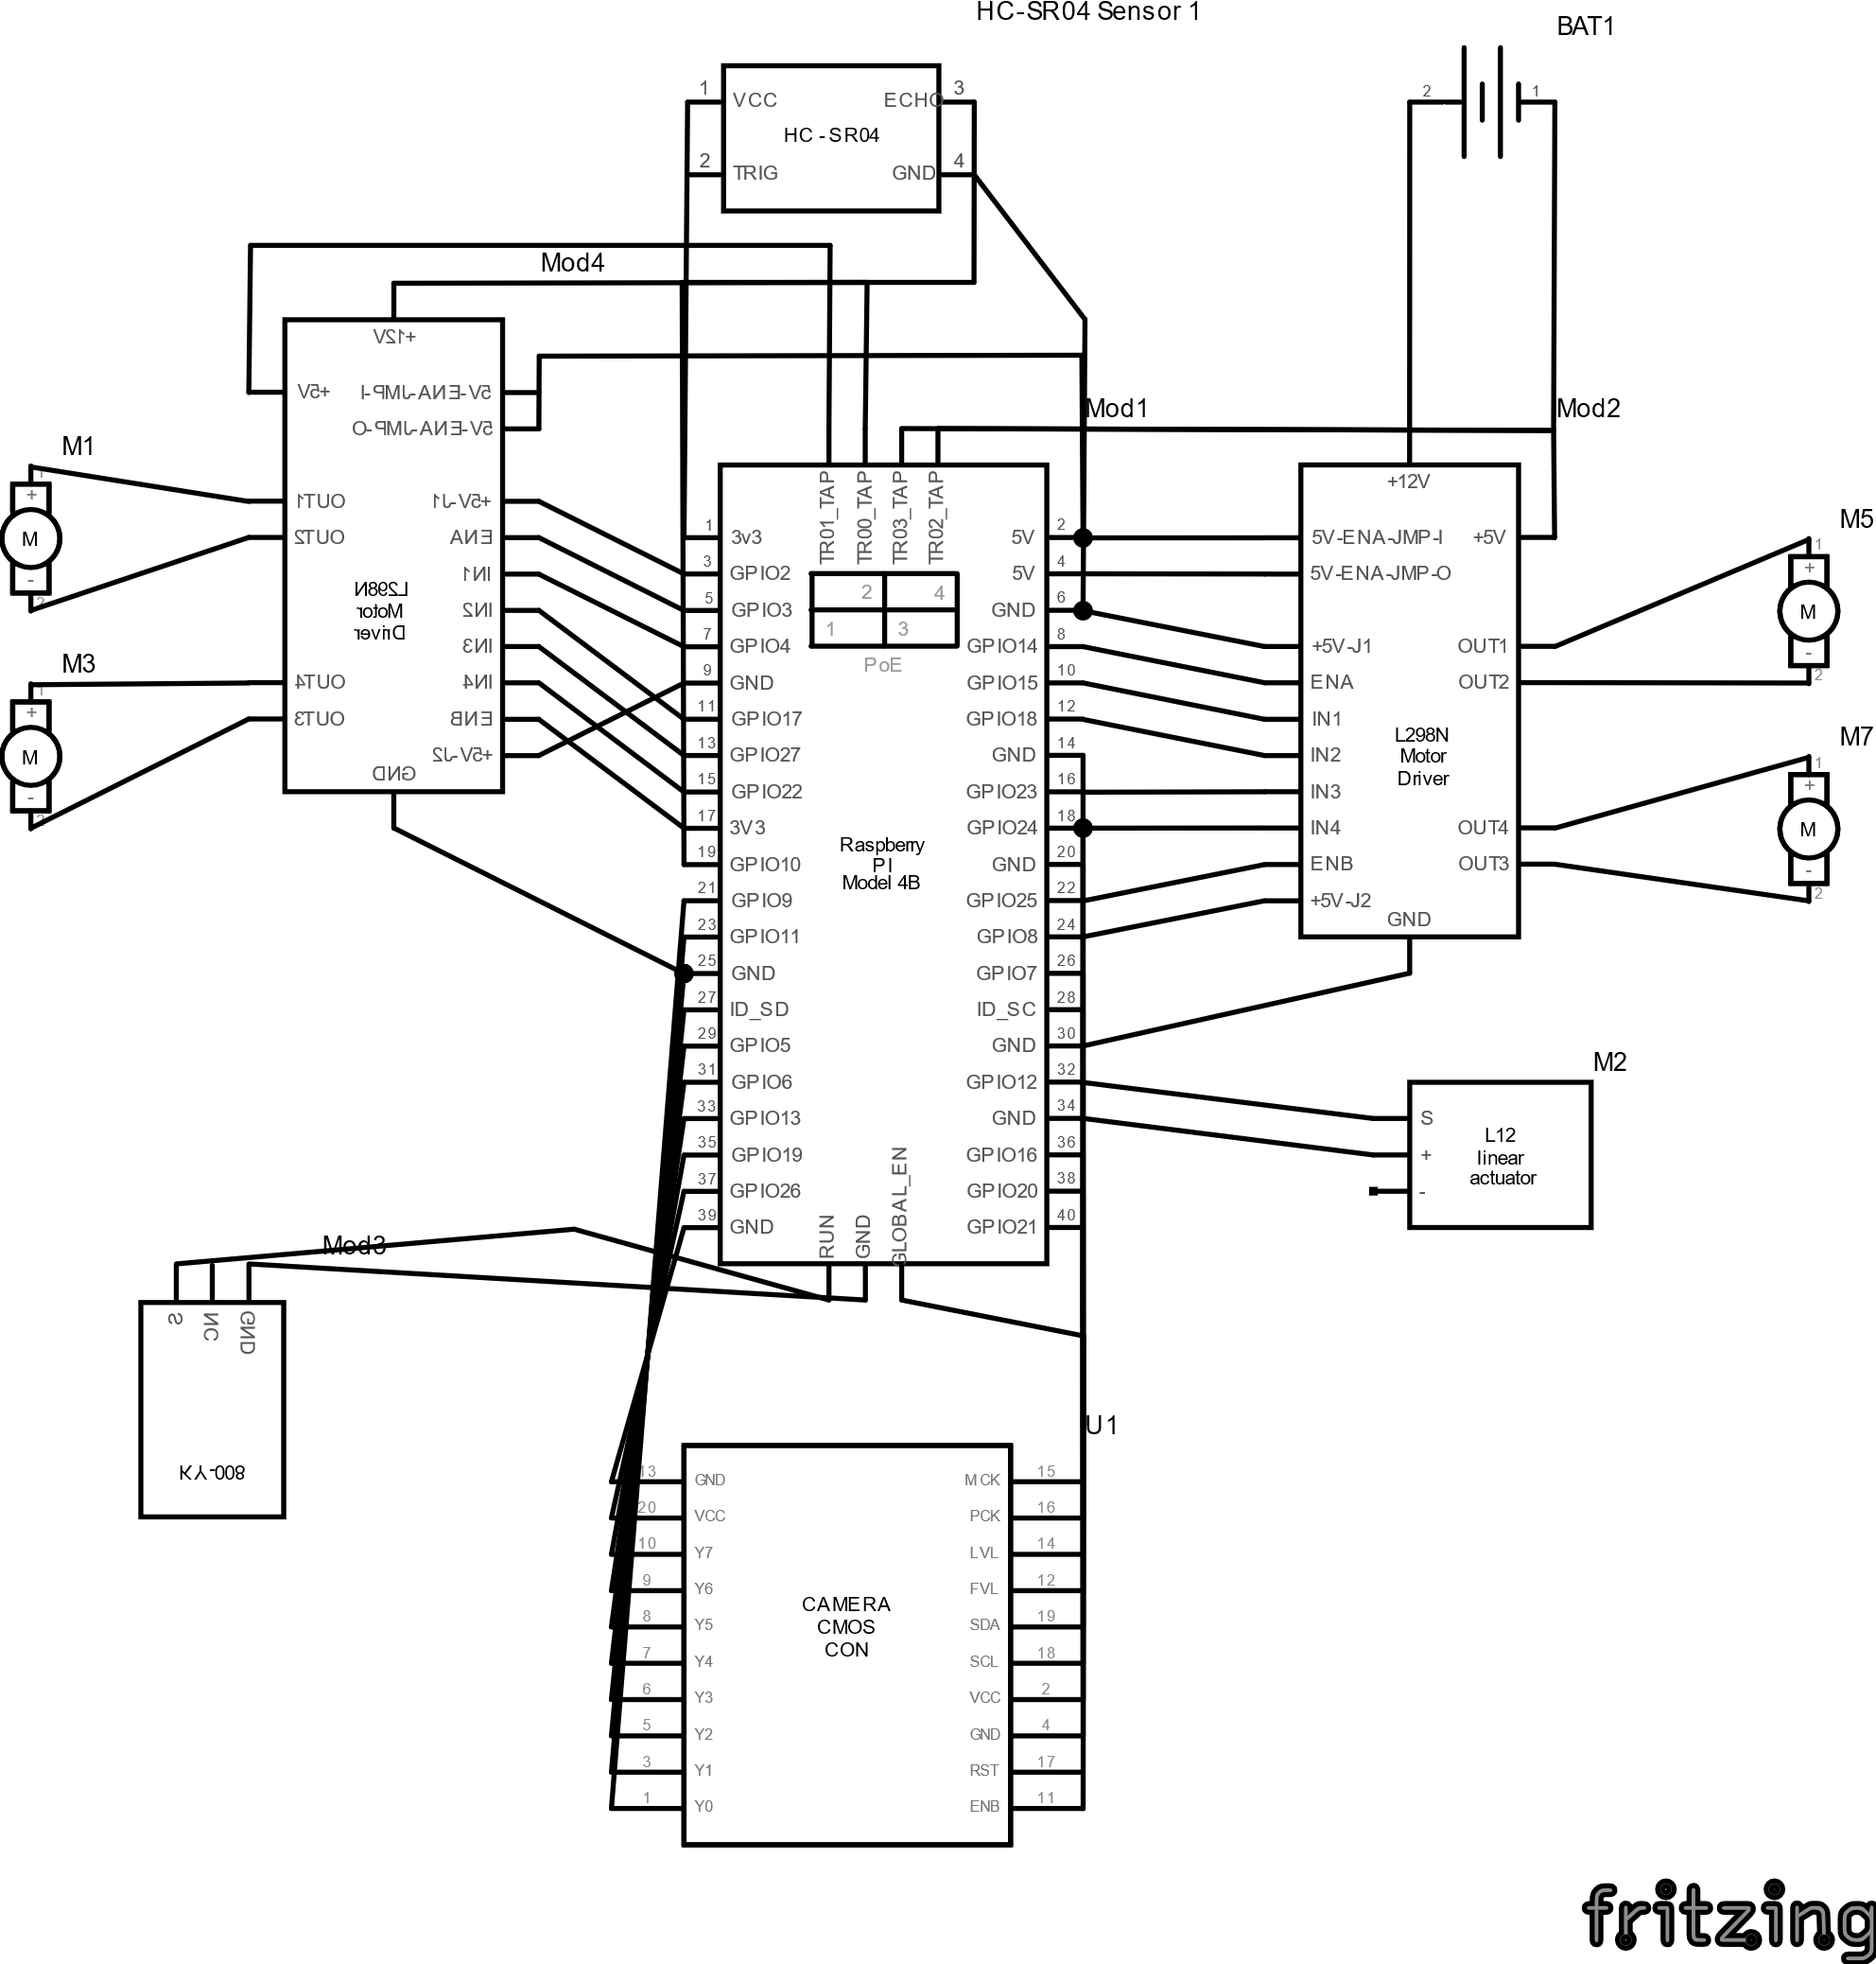

Figure : Electronics Configuration Schematic for Ray-Zer

# **Modelling & Analysis:**

## FEA:

FEA testing was conducted on some of the most critical and highly stressed components and assemblies of the design. This was done to ensure that the final product meets or exceeds the required performance criteria with a high degree of confidence and without any instances of failure. Five load cases were chosen to simulate the most common scenarios in which Ray-Zer will likely find itself in. All five cases have a factor of safety (FOS) of 1.5 applied to them in order to provide a margin of protection against potential failure or unexpected behavior. This number is reflective of the working environment in which Ray-Zer will be operating in, while also placing emphasis on its durability and reliability.

Testing consisted of five cases on three sub-assemblies: The front and rear wheel pieces of the rocker-bogie system, as well as the central chassis tube connecting them. These were selected due to the large number of delicate components such as plates and shafts integrated into the assemblies. They are also the modules that come into contact with the ground and bear the brunt of the loading with the external environment. All components were assigned the materials that are to be used in the actual product, fixed supports placed in areas to replicate real life constraints, and mesh refinements employed in areas anticipated to experience large stresses and loads for more accurate results. Figure below provides a graphical representation of all five load cases simulated.

### Explanation of test cases and loads

Test Case 1 was simulated to demonstrate a scenario whereby Ray-Zer tips over, experiences an impact at the rear wheelbase and placing its entire mass on the concentrated area. A representative force of 367.5N has been applied at the wheel-shaft connection plate. This figure was obtained by taking Ray-Zer’s mass plus an additional 10kg, or 98N of force.

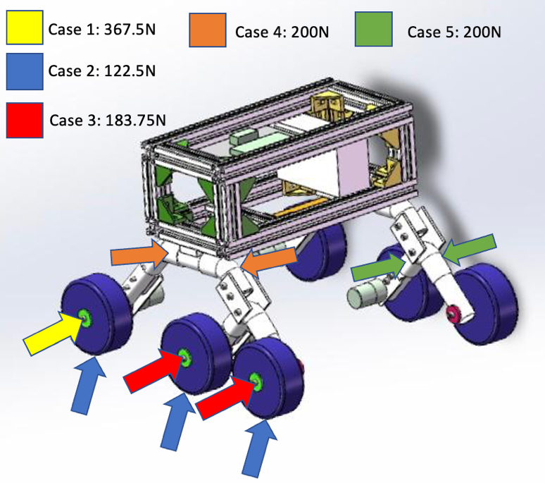Test Case 2 involved placing three 122.5N (367.5N/3) loads below each wheel acting at 20°. This simulates a scenario in which part of Ray-Zer’s body is suspended, with only one of its sides (right) remaining in contact with the ground.

Case 3 is similar to Case 1, but now the 367.5N load is distributed evenly (183.75N) between the two front wheels of the assembly as illustrated in Figure.

Test Case 4 sets out to simulate an event in which two opposing 200N loads are placed on the central PVC chassis connection. This will examine whether the component can resist deformation when both the front and rear wheel assemblies attempt to move in opposite directions. Similarly, Case 5 examines the scenario in which the 90° PVC section of the front wheel assembly is loaded with two divergent 200N lateral loads. This simulated the scenario in which Ray-Zer’s front wheel assembly becomes entrapped between rocks, causing it to twist. More detailed graphics describing the loading cases have been included below.

Figure 20 – Breakdown of Load Cases 1, 2, 3, 4, and 5

### FEA Analysis

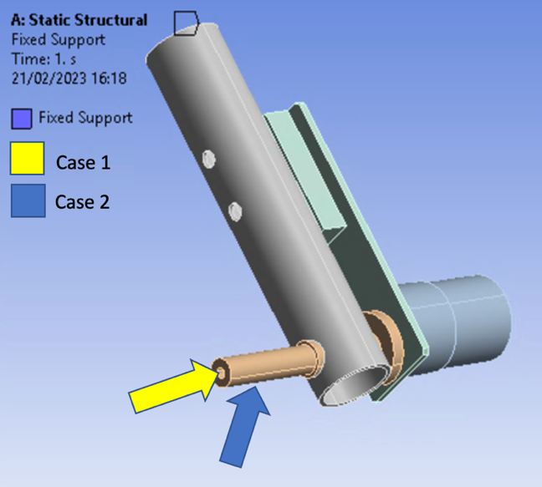Rear Wheel assembly: A fixed support was placed at the tube end to replicate the real-world connection to the rest of the Rocker-Bogie assembly. Loading Case 1 was placed at the shaft end with an angle of 20° from the horizontal while Case 2 was applied upwards as seen in Figure. The wheel was excluded from the analysis/ suppressed due to its large deformations as a result of its material (rubber). Key component under investigation was the motor bracket plate.

Throughout both analyses, the stress levels observed in all components were found to remain well below the yield strength of their respective materials. This confirms that the assembly can undergo sizeable mechanical loading in various different ways without coming close to failure. The subsequent deformation plots (Figure) reveal no major deformation, while the largest deflections occurred on the motor (3.1mm) and plate (» 2.6mm) as well as the wheel hub shaft (2.3mm) for Cases 1 and 2 respectively. The PVC tubing experienced minimal deformations and performance therefore remains unaffected.

Figure 21 - Detailed Breakdown of Rear Wheel Assembly Loads

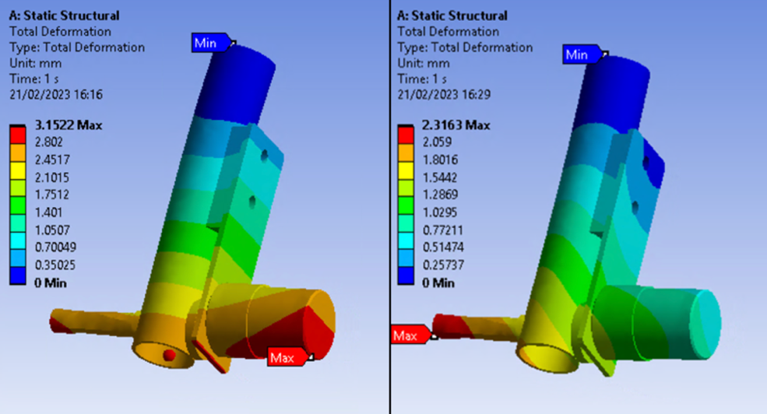

Figure 22 - Front Wheel Assembly Deformation Plots

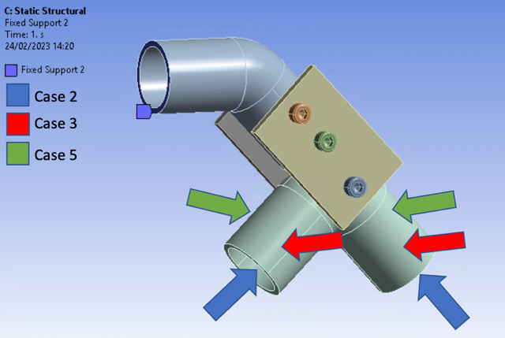Front Wheel Assembly: Loading cases 2, 3, and 5 were applied to the front wheel assembly as seen in Figure, while a fixed support was placed at the tube end to replicate the real-world connection to the rest of the Rocker-Bogie assembly. Wheels were again excluded from the analysis/ suppressed due to reasons previously mentioned. Connections between the 90° PVC swivel tubing, pivot plates and screw were set to frictional in order to replicate how the components would interact in real-life. Key components under investigation were the side pivot plates when subjected to twisting and bending.

The simulations revealed that all components were able to withstand the loads placed upon them in all three scenarios. The largest strains in each case were experienced at the 90° PVC bends and side pivot plates, but again remained well below material yield points. No significant deformations occurred anywhere in the assembly. The largest deflections in Cases 2, 3, and 5 were all witnessed at the tube end (2.9mm, 1.09mm, and 5.33mm respectively), with the plate experiencing minor levels of deformation as well (Figure). These are all small in magnitude and will therefore not affect the performance nor the reliability of Ray-Zer in any way.

Figure 23 - Detailed Breakdown of Front Wheel Assembly Loads

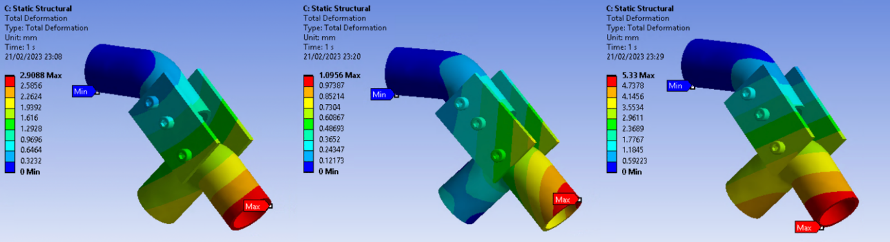

Figure 24 - Deformation plots for front wheel assembly Case 1 (left), Case 2 (middle), and Case 3 (right)

Central Chassis Tubing Assembly: Fixed supports have been added to the top of the chassis connection plate, as well as to both tube ends, thus constraining the assembly, and closely simulating real-world conditions. Case 2 involved placing two loads of equal magnitude normal to the tube ends, therefore translating the force applied at the wheels into the central assembly. This was then repeated with only one of the loads applied to the right end. Case 4 involved two opposing forces acting perpendicular to the chassis as seen in Figure. Tube ends were key components under investigation.

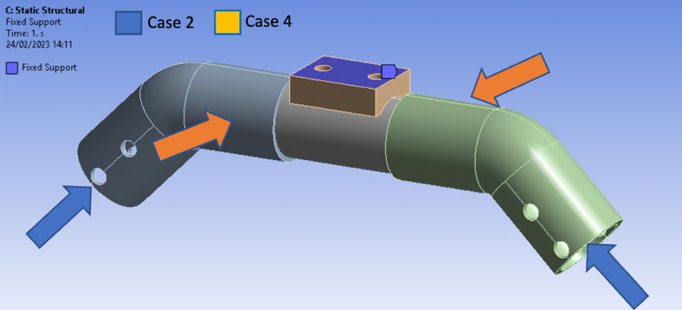

Figure 25 - Detailed Breakdown of Central Chassis Tubing Assembly Loads

Some noticeable deflections were witnessed in Case 2, with deformations measuring 20.5mm and 31.14mm. These were recorded in the scenarios whereby loads were positioned at both ends and at a singular end respectively. Although visible, these distortions remain within tolerable limits, and will therefore fail to affect system performance in any meaningful way. Case 4 on the other hand resulted in negligible levels of deformation (3.61mm) occurring at either end of the tube assembly as observed in Figure. All components remain well within their material yield limits.

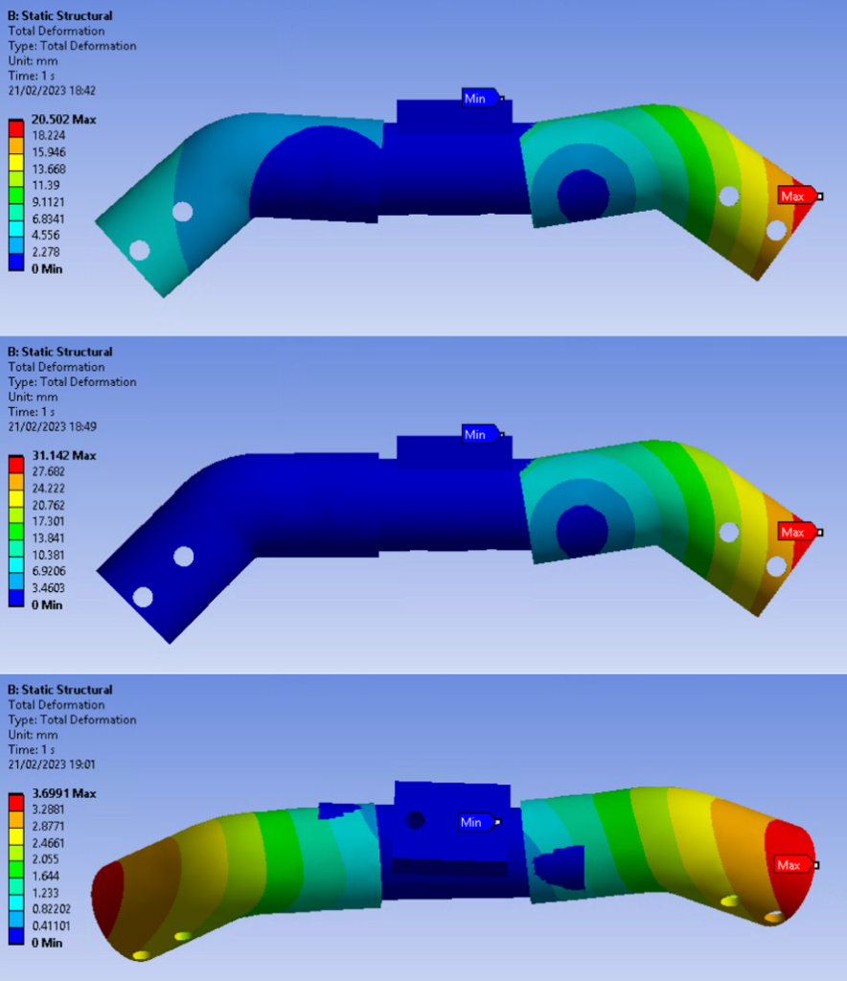

Figure 26 - Central Chassis Tubing Assembly Deformation Plots

### Concluding Remarks

In conclusion, the Finite Element Analysis (FEA) conducted on the Rocker-Bogie chassis offered reassuring results - no failures were observed throughout the stress and strain simulations. These outcomes showcase the resilience of our design, contributing to an overall robust and reliable vehicle. The examination primarily focused on several loading conditions, with each replicating a diverse real-world scenario. Regardless of the situation, the chassis consistently exhibited stability and structural integrity, thereby confirming the effectiveness of the design approach.

Although the design withstood all loads placed on it, optimisation remained a valuable undertaking. Enhancements were therefore made to reduce material usage, lower weight, and improve cost savings and performance without sacrificing on durability. Such measures included refining component geometry, reducing tube thickness and cross-sectional size, as well as adjusting material selection. Critical components including the Rocker-Bogie pivot plates, motor bracket plates, and central chassis connection pieces all underwent a material transformation after the completion of the FEA analysis from metal alloys to lighter, cheaper, and more easily manufacturable 3D printed polymers. Overall, the FEA analysis indicates a promising starting point for the Rocker-Bogie chassis.

# **Prototyping:**

To evaluate the prototype's effectiveness, a comparison must be made to the evaluation criteria for the final product, including effective weed removal, minimal crop damage, and low power consumption. Essential characteristics for the final product include ease of use, durability, and affordability. Field tests will be conducted to determine the prototype's performance in meeting these criteria. Adjustments will be made where necessary to ensure it meets the standards set by the final product.

Table 7 - Features present in the real product and prototype.

|  |  |  |
| --- | --- | --- |
|  | **Real product** | **Prototype** |
| Camera | ✓ |  |
| Lidar | ✓ |  |
| Raspberry Pi | ✓ |  |
| Rocker-Bogie | ✓ | ✓ |
| Battery | ✓ | ✓ |
| Diode Laser | ✓ |  |
| Laser Pointer |  | ✓ |
| Actuator | ✓ | ✓ |
| Solar Panel | ✓ |  |
| Metal frame | ✓ | ✓ |
| Motor | ✓ | ✓ |
| Weed identification system | ✓ | ✓ |
| Navigation system | ✓ | ✓ |

So based on the design and modelling steps determine the basic features of Ray-Zer. Table xx is presented to compare the features of the real product and the prototype. And following the previous discussions on hard requirements and budgets, all essential features and USP will be included in the minimum viable product. The initial prototype of the Ray-Zer focused on testing its operation in different terrains. The design and framework of the Rocker-Bogie was therefore refined during the prototyping. The software development of the initial prototype was also carried out. This included the addition of a weed species recognition function and a route planning function.

* **Navigation system**: This system is integral to efficient weed targeting and minimal crop damage. A GPS module has been used to obtain coordinates and log positional data. And real-time GPS coordinates guide Ray-Zer’s path, determine its current location, and help avoid obstacles. Our prototype was tested under conditions replicating Brazilian agricultural fields, which typically have neat paths flanked by crops.
* **Weed Identification system**: The prototype’s weed identification system uses DeepWeed’s (<https://www.nature.com/articles/s41598-018-38343-3>) advanced technology, employs machine learning to distinguish weeds from crops. This technology can analyse images, weeds are identified based on distinctive characteristics such as colour, shape and texture. This precision ensure real product targeted weed removal, and leaving crops unaffected.
* **Rocker-Bogie**: This is a highlight feature, as it allows Ray-Zer to operate effectively in a range of complex terrains. Its construction from PVC tubing enhances its flexibility and due to its sufficient strength (52 MPa Ultimate Tensile Strength) and low density (1.38g/cm3)( https://www.vinidex.com.au/technical-resources/material-properties/pvc-properties/), which reduces the mass by half compared to an aluminium design. Furthermore, its unique suspension helps maintain balance and stability, ensuring the robot’s components (battery, laser pointer etc.) remain level even on uneven surface. During the prototype testing process, various inclination angles were explored, and obstacles were placed on the ground. The test demonstrated the practicality and effectiveness of the rocker-bogie, showcasing its ability to adapt to different terrains.
* **Laser**: To simulate the weed removal process, a laser pointer will be used instead of a real laser. And there are many successful examples of laser weed control in past studies. This will minimize associated costs and safety risks when testing.
* **Battery, Metal frame and Motor**: Key components that characterize the product and enable the MVP to operate to minimum standards set by the final design. The battery chosen for the prototype has a capacity to power the robot for 7 hours. While battery endurance is not the primary focus for the prototype stage, it will be a significant consideration for the final product. To address this in the future, the development of charging station is planned.

## Prototype Processing Plan:

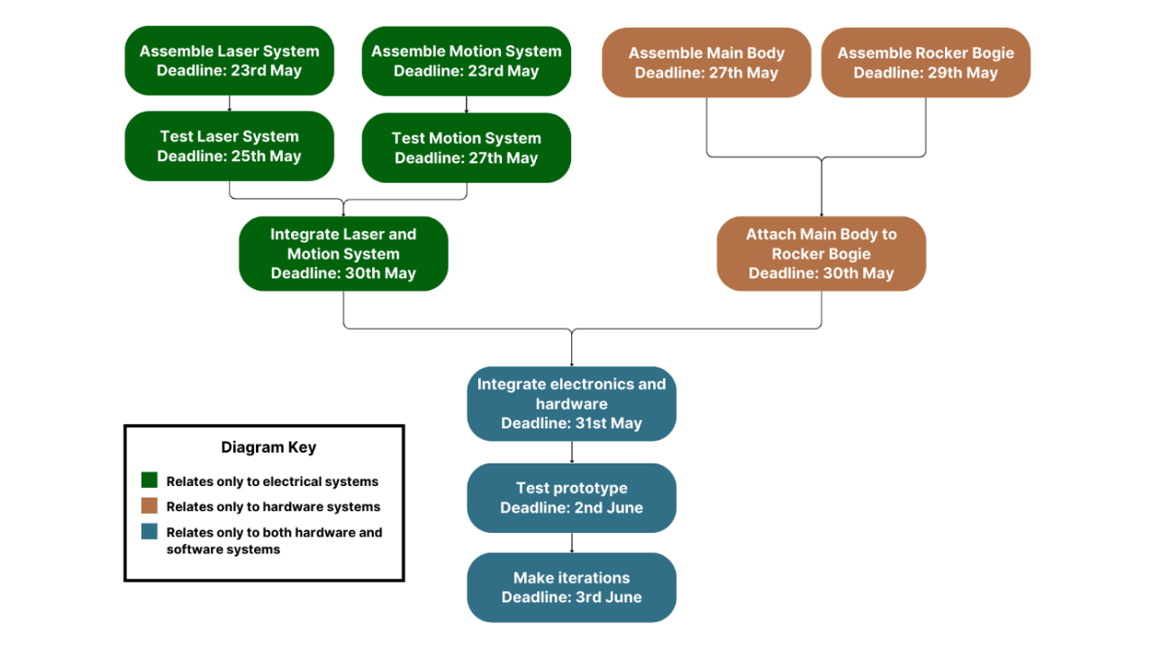

Figure 27 - Prototype Process Plan

A four-section assembly process is illustrated in Figure xx, with two hardware and two electronic sections. This enables multiple group members to work simultaneously, optimizing time efficiency. The laser and motion systems will be integrated with the main body and rocker bogie suspension, and the hardware and electronic systems will be merged to build the complete prototype. The robot's functionality will be tested, such as navigating a short obstacle course and operating the laser system accurately. Any necessary modifications will be made to ensure the successful operation of the final presentation.

## List of Part and Budget:

Table 8 - Prototype parts list and costs

|  |  |  |  |  |
| --- | --- | --- | --- | --- |
| **Item** | **Quantity** | **Cost** | **Estimated Arrival Dates** | **Total Cost** |
| Battery | 1 | £15.40 | 15th May | £15.40 |
| Arduino Mega | 1 | £45.68 | 15th May | £45.68 |
| GPS Module | 1 | £12.99 | 15th May | £12.99 |
| Ultrasonic Sensors | 3 | £3.48 | 16th May | £10.44 |
| DC Motor | 4 | £13.87 | 20th May | £55.48 |
| Laser Pointer | 1 | £1.72 | 14th May | 1.72 |
| Laser Adapter | 1 | IH-M | 14th May | - |
| Rail/stepper motor module | 1 | £69.99 | 20th May | £69.99 |
| Rail/stepper motor module adapter | 1 | IH-M | 20th May | - |
| T Slot Bar (40cm) | 4 | £2.91 | 14th May | £11.64 |
| T Slot Bar (20cm) | 4 | £1.47 | 14th May | £5.88 |
| T Slot Bar (15cm) | 4 | £1.76 | 14th May | £7.04 |
| T Slot Bar connectors | 24 | IH-M | 14th May | N/A |
| M6 Nut & Bolt | 50 | £1.60 | 17th May | £80 |
| Acrylic Body Panel (40cm X 15cm) | 4 | £5.75 | 20th May | £23 |
| Acrylic Body Panel (40cm X 20cm) | 4 | £5.75 | 20th May | £23 |
| PVC Pipe | 1 | £43.62 | 12th May | £43.62 |
| Wheels | 6 | £3.16 | 20th May | £18.96 |
| Wheels Adapter | 6 | IH-M | 18th May | - |
| Motor drivers | 2 | P-A | 20th May | - |
|  |  | | **Total:** | £423.84 |

IH-M: In-House manufactured, therefore no need to purchase item.

P-A: Previously Acquired, therefore no need to purchase item.

The acquisition of materials and components, as stated in Table x, will adhere to a planned schedule. Each element has been ordered with enough lead time to ensure they arrive well before the prototype assembly begins, and also to ensure that expenditure does not exceed the budget of £500. The prototype will use the same materials as the commercial robot, except for the adapters and body panels. Adapters will be 3D printed with PLA for ease of low scale manufacturing, while the commercial robot will use steel casting. Acrylic will be used for the prototype's body panels to enhance visibility during presentations, while the commercial robot will have steel body panels.

## Evaluation of the prototype:

Table 9 - Evaluation of the prototype against the evaluation criteria

|  |  |  |
| --- | --- | --- |
| **Evaluation Criteria** | **Method of Evaluation** | **Results** |
| **Functionality (Ability to identify and target weeds)** | Examine how accurately the prototype identifies and targets weeds in different crop fields. | Meet all functional requirements |
| **Performance (Weeding efficiency and working hours)** | Calculate the frequency of weeding and estimate with existing sources | Highly efficient |
| **Ease of Use (User interface, controls)** | Introduced the prototype to farmers in Brazil, interviewed them and collected their suggestions | Received positive feedback from farmers |
| **Durability (Resistance to weather conditions, wear and tear)** | Expose the prototype to various environmental conditions and measure its performance | Showed robustness and durability |
| **Compliance (Regulations and standards)** | Ensure the prototype complies with all relevant regulations and standards | Fully compliant |
| **Cost-effectiveness (Initial and operating cost)** | Calculate the prototype's initial and operating costs and compare them to potential savings | Proved to be cost-effective |

Based on Table xx, the results are highly positive across all criteria.

* **Functionality**: The prototype has shown significant capabilities, being able to distinguish 17 different types of weeds with an accuracy rate of over 80%. Future work for real product should focus on improving the machine learning algorithms to enhance weed identification accuracy and expanding the database of weed types.
* **Performance**: The prototype was set to run at 8 miles per hour and is projected to weed 15-20 acres farmland daily. (https://carbonrobotics.com/) In the actual product, a combination of solar panels and backup batteries will be used to ensure consistent power supply.
* **Ease of Use**: The feedback from the Brazilian farmers was positive, 90% of them reported that the prototype was easy to learn to use and willing to use it. So will continue collecting feedback and improve areas of the interface and controls to improve user experience.
* **Durability**: The prototype exhibited high durability, through simulating conditions such as rainy weather and entanglement with plants. The prototype shows and excellent ability to navigate these challenges. Rocker-Bogie and the steel frame playing significant roles in its resilience.
* **Compliance**: The prototype meets all relevant regulations and standards. However, it’s still essential to remain updated and ensure ongoing compliance for real product manufaction.
* **Cost-effectiveness**: Preliminary calculations show that due to the Lay-Zer Mk1’s effective weed control and high efficiency, it has the potential to offset initial investments. Besides, an excellent business plan needs to be developed for the real product to fully realize this potential.

# **Manufacturing:**

## Manufacturing Requirements:

### Parts List

Table 10 - Actual product parts list

|  |  |  |  |  |  |
| --- | --- | --- | --- | --- | --- |
| **Item** | **Supplier** | **Location of supplier** | **Quantity** | **Cost per unit** | **Total Cost** |
| Battery | RS | UK | 1 | £20.87 | £20.87 |
| Arduino Uno | KunKune | UK | 1 | £6.21 | £6.21 |
| GPS Module | KunKune | UK | 1 | £4.41 | £4.41 |
| Ultrasonic Sensors | KunKune | UK | 3 | £1.31 | £3.93 |
| DC Motor | Farnell | UK | 4 | £2.16 | £8.64 |
| Laser | Endurance Lasers | USA | 1 | £118.00 | £118.00 |
| Laser Mount | IN-HOUSE | - | 1 | £0.50 | £0.50 |
| Actuator | EYPINS | UK | 1 | £24.36 | £24.36 |
| Actuator Mount | IN-HOUSE | - | 1 | £1.20 | £1.20 |
| T Slot Bar  (1 metre) | RS | UK | 3 | £16.09 | £48.27 |
| T Slot Mount | Motedis | UK | 24 | £0.79 | £18.96 |
| M6 Nut & Bolt | RS | UK | 50 | £1.26 | £63.00 |
| Body panels | RS | UK | 6 | £1.94 | £11.64 |
| PVC Pipe | Screwfix | UK | 1 | £5.00 | £5.00 |
| Wheels | RS | UK | 6 | £2.65 | £15.90 |
| Wheels Mounts | IN-HOUSE | - | 6 | £0.80 | £4.80 |
| Motor Driver | KunKune | UK | 2 | £3.51 | £7.02 |
| Lidar | RS | UK | 1 | £63.47 | £63.47 |
| Camera module | RS | UK | 2 | £18.08 | £36.16 |
| Raspberry Pi | RS | UK | 1 | £69.39 | £69.39 |
| Solar Panel | RS | UK | 1 | £56.71 | £56.71 |
| **Total:** | | | | | **£588.44** |

IN-HOUSE: Manufacturing will be completed in Activelio’s Manufacturing Facility using FDM 3D Printing, as parts are custom and tooling cost will be too expensive using other methods like steel casting.

### Supply chain

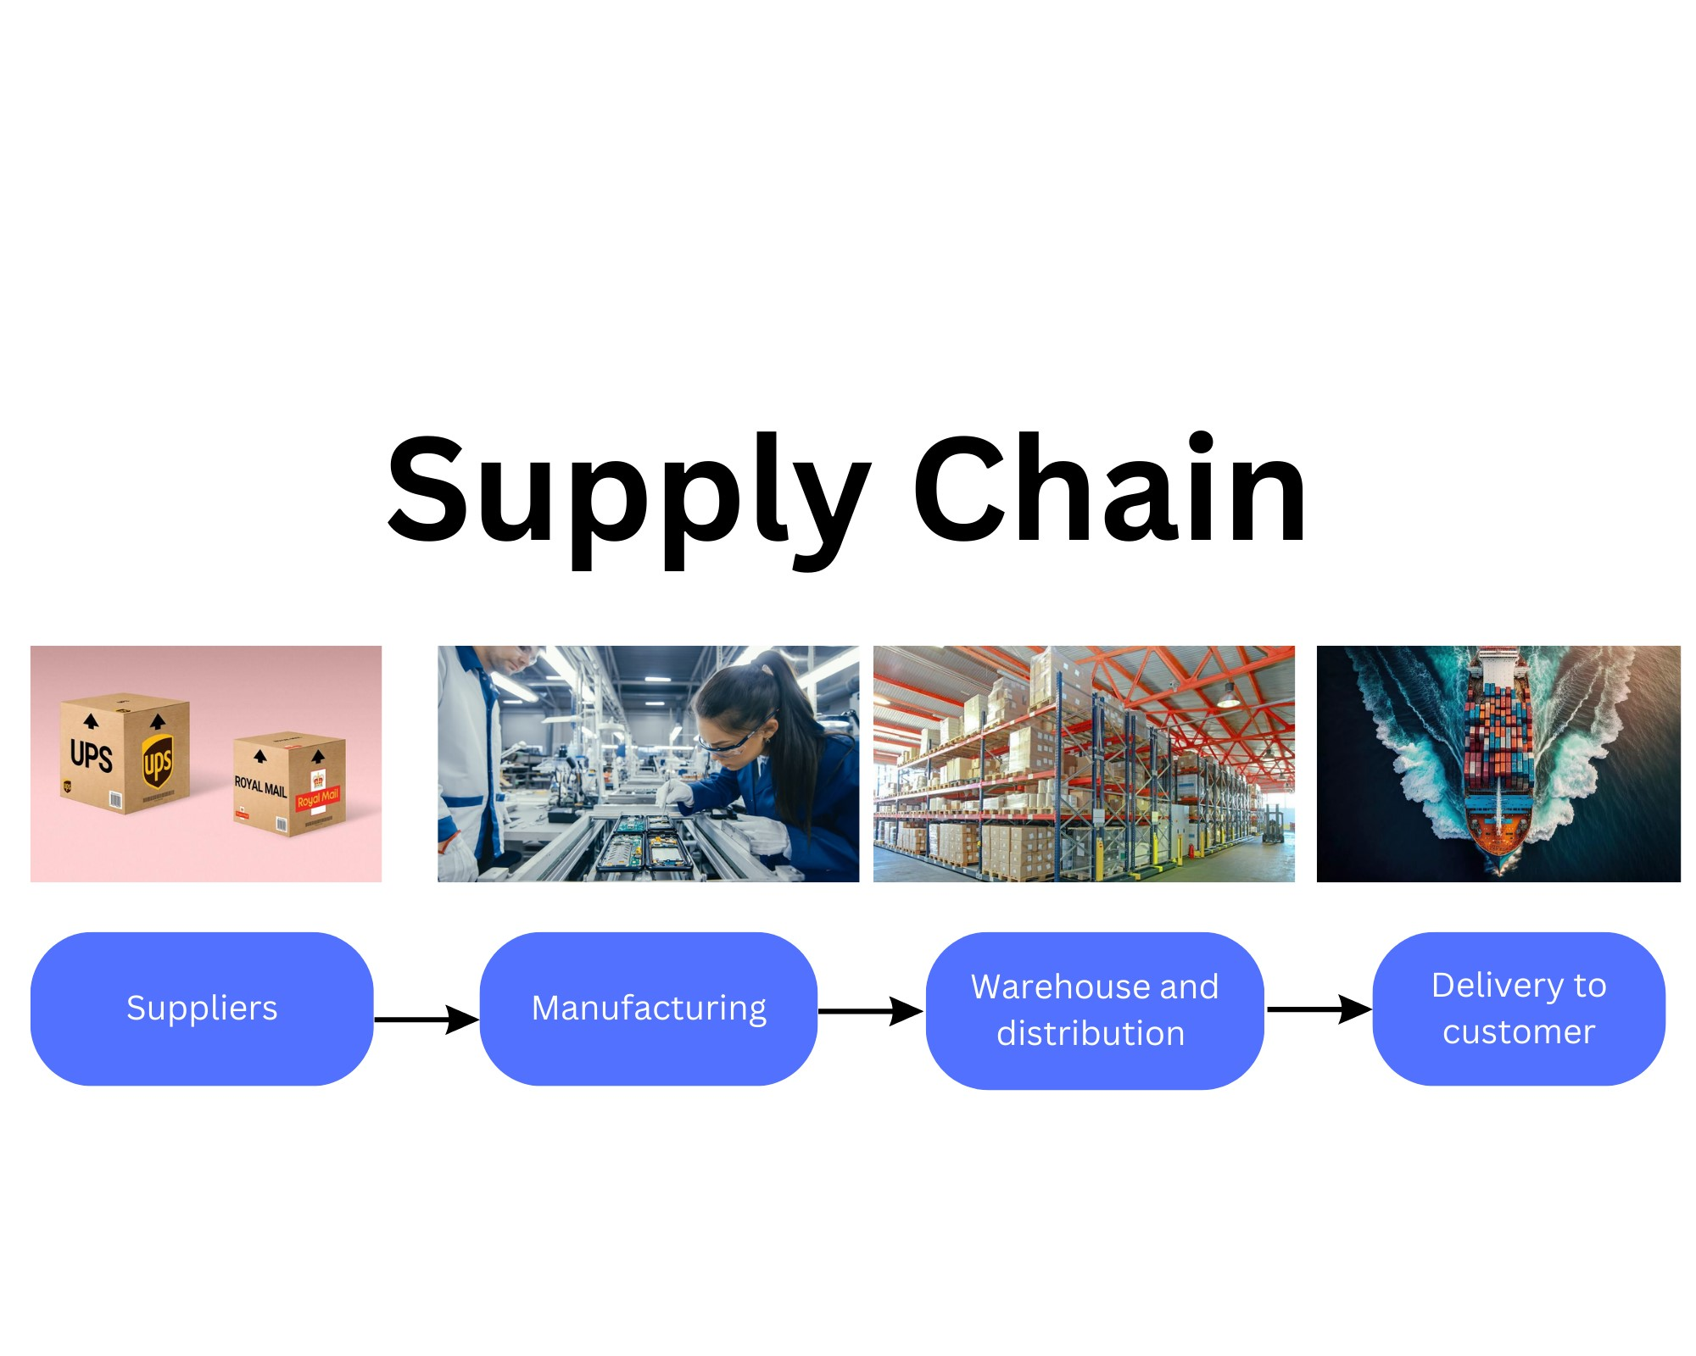

Figure 28 - Supply chain structure

Activelio AgriTech’s supply chain framework aims to scalable, as mentioned earlier, the initial stage involves receiving components from suppliers, which are transported to Activelio's manufacturing facility in Suffolk. The selection of this location was based on its advantageous proximity to Felixstowe, a prominent port in the UK, granting convenient access to various countries, including Brazil and South America. Once the production of the Ray-Zer Mk1 is finalized and testing is completed, it will be transferred to the Brinor Warehousing & Distribution centre. During this phase, it will be prepared for international delivery.https://www.portman-logistics.com/news/all-about-port-of-felixstowe/

### Suppliers

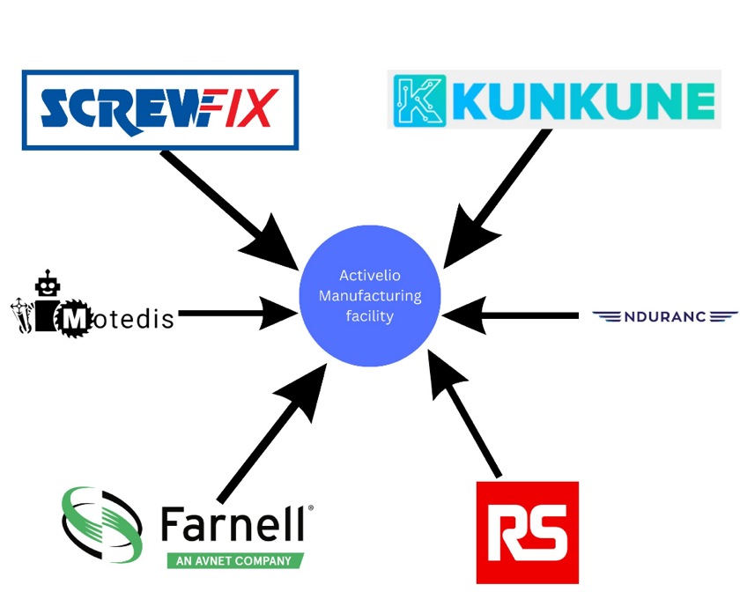

Figure 29 - Components and parts suppliers schematic

Figure xxxx outlines the selected suppliers which will be used in the manufacturing process for the

Ray-Zer Mk1. The criteria for supplier selection primarily focused on their geographic proximity within the United Kingdom, enabling efficient communication channels in the event of any component-related issues. Furthermore, all chosen suppliers have strong reputations within the industry including RS, Farnell, and Screwfix.

## Analysis of Manufacturing Global Options:

An analysis was complete to assess the most appropriate country for the manufacturing and assembly of the product. Potential viability was evaluated using key objectives which included:

* Cost optimization
* Labour availability
* Market access
* Environmental Consideration
* Proximity to suppliers

Cost optimization was assessed by analysing:

* Proximity to customer
* Cost of labour
* Cost of overhead

Labour availability was assessed by the amount of engineers produced each years within each prospective country. This is an important assessment as Activelio AgriTech is a technology-driven company using technologies such as AI and motor control. Thus, a highly skilled and intellectually adept workforce is vital to cultivate a culture of continual innovation and propel the company towards sustained growth.

Market access will be examined to determine the geographical proximity and connectivity of potential countries, including the United States, Europe, and Asia. This assessment will be used to rate the ease of growth as Activelio envisages expansion into more developed countries in the future. By strategically considering market access, Activelio can effectively position itself to capitalize on opportunities in diverse regions and foster international growth.

Environmental consideration will evaluate environmental protection through a country’s regulations. This holds significant importance for Activelio, as the company strives to manufacture its products in nations that actively promote sustainability.

Proximity to suppliers will be examined based on the geographical distance between the manufacturing country and the primary component suppliers. As depicted in Figure XXXX within the manufacturing section of this report, most components are supplied from the United Kingdom (UK). This is an important factor as distance between supplier and manufacturing facility can dictate the responsiveness in addressing any supply-related challenges. By prioritizing local or nearby suppliers, potential issues can be swiftly resolved, minimizing disruptions compared to distant suppliers located on the opposite side of the globe.

6 countries were selected based on an article which suggests 10 countries which are most suitable for manufacturing robotics, this includes:

* Japan
* China
* USA
* Germany

Two other countries were added because of their proximity to suppliers and the primary customer, this includes UK and Brazil respectively.

<https://www.analyticsinsight.net/top-10-countries-making-the-best-out-of-robotics-in-2022/>

Not all 10 countries were selected from the article as some countries are quite similar this includes.

* South Korea
* Canada
* Italy
* Sweden
* Denmark
* Taiwan

Figure XXXX illustrates the weighting of different categories based on their significance to Activelio's entrepreneurial success. The determination of these weights was reached through a collective decision-making process involving all group members. The most important category which was selected was cost optimization, given the company's objective of establishing a profitable business.

Furthermore, labour availability and market access are also important factors for Activelio's long-term viability, thus meriting a weighted score of 4 out of 5. Recognizing the vital role of a skilled workforce and accessible markets, these categories are essential for Activelio.

Conversely, environmental consideration and proximity to suppliers, while still significant, were scored slightly lower priority compared to the previously mentioned categories. Nevertheless, their importance in maintaining responsible and sustainable operations is considerable.

The weighting framework used enables Activelio AgriTech to prioritize categories based on importance to achieving commercial success.

Table 11 - Design criteria weighting

|  |  |
| --- | --- |
| **Categories** | **Weight Amount** |
| Cost Optimization | 5 |
| Labour Availability | 4 |
| Market Access | 4 |
| Environmental Consideration | 3 |
| Proximity to suppliers | 3 |

Table 12 – Weighted results of global options assessment

|  |  |  |  |  |  |  |  |  |  |  |  |  |
| --- | --- | --- | --- | --- | --- | --- | --- | --- | --- | --- | --- | --- |
| **Country** | **Cost Optimisation** | | **Labour Availability** | | **Market Access** | | **Environmental Consideration** | | **Proximity to suppliers** | | **Total score** | |
| **Before weight** | **After weight** | **Before weight** | **After weight** | **Before weight** | **After weight** | **Before weight** | **After weight** | **Before weight** | **After weight** | **Before weight** | **After weight** |
| **Japan** | 2 | **10** | 5 | **20** | 1 | **4** | 3 | **9** | 1 | **3** | 11 | **46** |
| **China** | 5 | **25** | 3 | **12** | 1 | **4** | 1 | **3** | 1 | **3** | 11 | **47** |
| **UK** | 2 | **10** | 4 | **16** | 4 | **16** | 5 | **15** | 5 | **15** | 20 | **72** |
| **USA** | 2 | **10** | 5 | **20** | 4 | **16** | 4 | **12** | 3 | **9** | 18 | **67** |
| **Germany** | 2 | **10** | 5 | **20** | 3 | **12** | 5 | **15** | 4 | **12** | 18 | **69** |
| **Brazil** | 4 | **20** | 2 | **8** | 5 | **20** | 1 | **3** | 3 | **9** | 15 | **60** |

Within the category of cost optimization, China has emerged as the top performer, primarily attributable to its capacity to manufacture components at considerably lower costs than other competitors. This cost advantage can be attributed to China's abundant human capital, which enables access to a cost-effective labour force. Additionally, China has lower overhead expenses in comparison to countries like the USA and UK. Furthermore, its geographical proximity to South America offers logistical advantages, as transportation across the Pacific Ocean proves more efficient in terms of time and cost.

Japan, Germany, and the USA exhibited exceptional performance in the labor availability category, as a study suggests they are all in the top 10 countries known for producing highly skilled engineers worldwide. This positions these countries as prime sources for recruiting top talent, ensuring a smoother scalability process for Activelio when the time comes.

https://finance.yahoo.com/news/12-countries-produce-best-engineers-153649847.html

Brazil performed the best in market access due to its advantageous geographical location, which presents opportunities to expand throughout the South America region. In addition, Brazil has a favourable proximity to Africa which is reliant on the agricultural industry.

Additionally, the United Kingdom (UK) and the United States (USA) demonstrated strong performance in this category. The UK's location facilitates potential expansion into more developed Western European countries such as France and Germany. Similarly, the USA's geographical positioning allows for potential market access to Canada, Africa, and Western Europe.

The United Kingdom (UK) exhibited a strong performance in the environmental consideration category, primarily due to its proactive promotion of policies such as the Climate Change Act (2008). This legislation mandates greenhouse gas emissions reduction targets, compelling businesses to commit to sustainable practices.

https://friendsoftheearth.uk/climate/how-climate-change-act-helped-us-hold-government-account

Similarly, Germany received strong scores in this category, by having policies such as the Renewable Energy Sources Act (EEG). This initiative allows the expansion of renewable energy adoption within businesses by providing long-term contracts that incentivize the use of clean energy solutions into Germany's corporate landscape.

https://cms-lawnow.com/en/ealerts/2022/08/the-german-renewable-energy-sources-act-2023-eeg-2023-has-been-passed-a-new-framework-for-renewable-energy

Given that the majority of Activelio's suppliers are located within the UK, it follows that manufacturing the product in the UK would be the most advantageous option. However, it is important to note that several other countries have also performed well in the proximity to suppliers category, primarily due to their strategic geographical positioning. For instance, Germany, being situated in Western Europe, offers favourable proximity to key markets. Similarly, countries like the United States have the advantage of convenient access to the UK through shipping routes. These factors make these countries viable alternatives to consider for manufacturing, as they provide favourable logistics and potential market opportunities in alignment with Activelio AgriTech’s supply chain requirements.

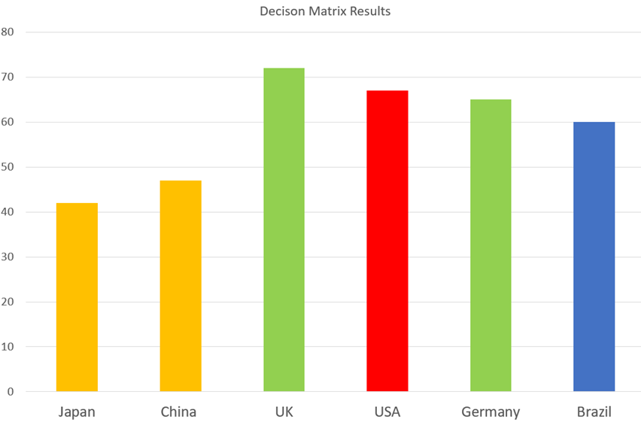

Figure 30 - Decision matrix results

As shown in Table XXXX and Figure xxxx, the United Kingdom (UK) is the most suitable country for the manufacturing and assembly of the Ray-Zer Mk1. Consideration was also given to other countries during this investigation, and some of these countries may become more relevant in the future when Activelio AgriTech transitions from mostly sourcing components from the UK to exploring options in Asia, such as China and Taiwan. This strategic shift would enable Activelio AgriTech to capitalize on the advantages offered by these regions in terms of manufacturing capabilities and supply chain optimization. While the UK currently stands out as the optimal choice, the evolving landscape of global manufacturing highlights the potential for future adaptations and expansions to other regions.

## Manufacturing Process:

This section of the report aims to show the assembly and manufacturing processes used within the Activelio AgriTech facility, with the objective to establish manufacturing credibility of Activelio AgriTech to potential investors and individuals interested in the company.

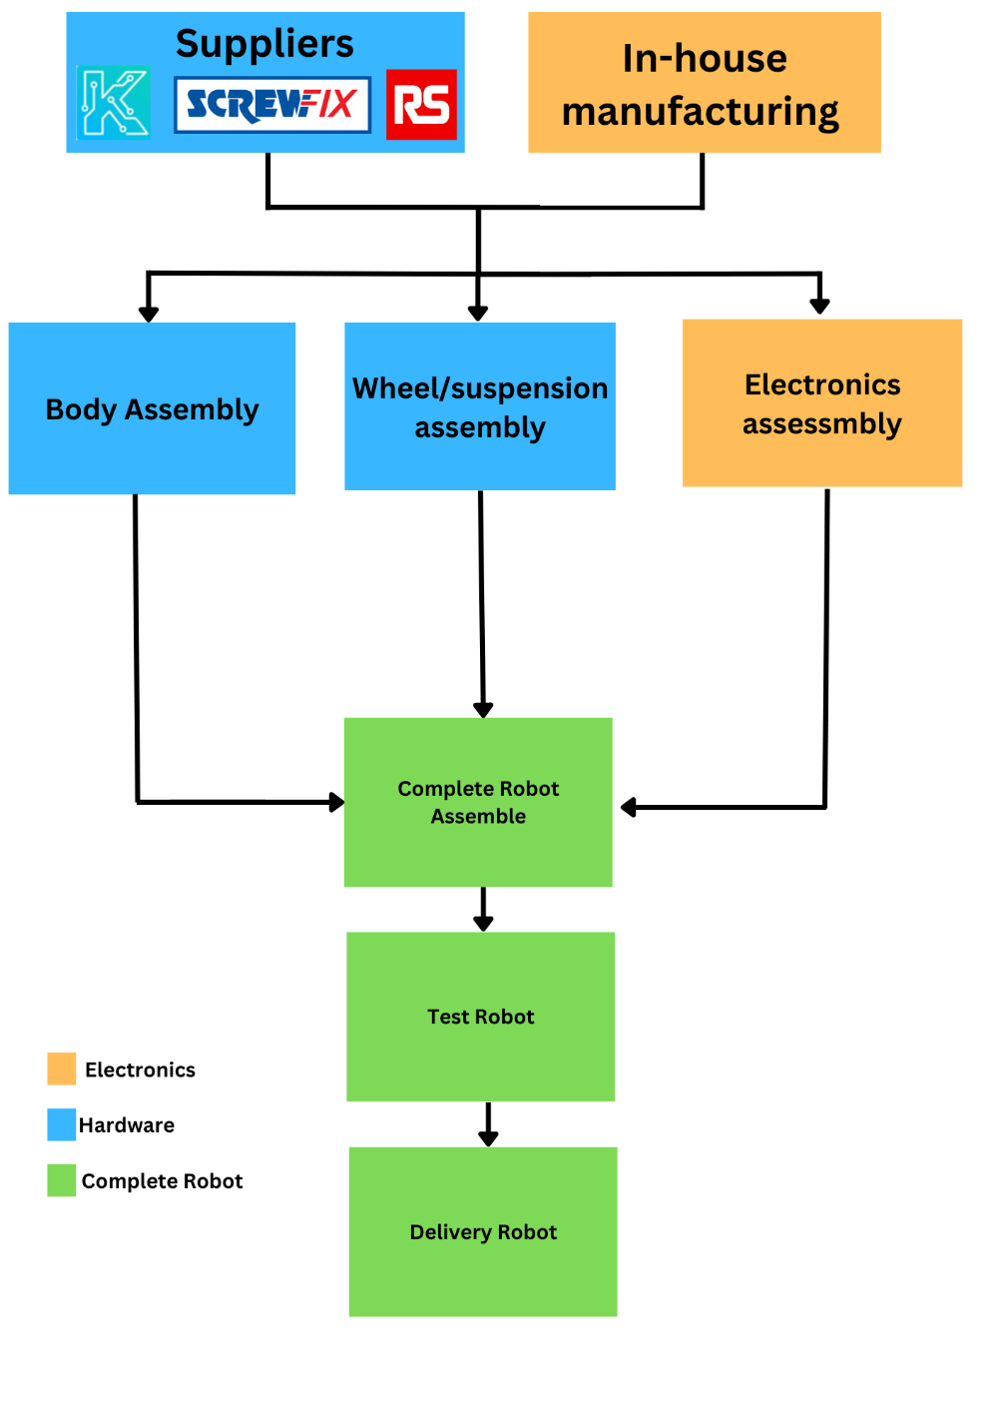

Figure 31 - Overview for manufacturing and assembly process

Figure XXXX presents an overview of the entire manufacturing process, showing the journey from supply to delivery. A more detailed breakdown will be later provided to showcase the assembly process of the body, wheel/suspension and electronics.

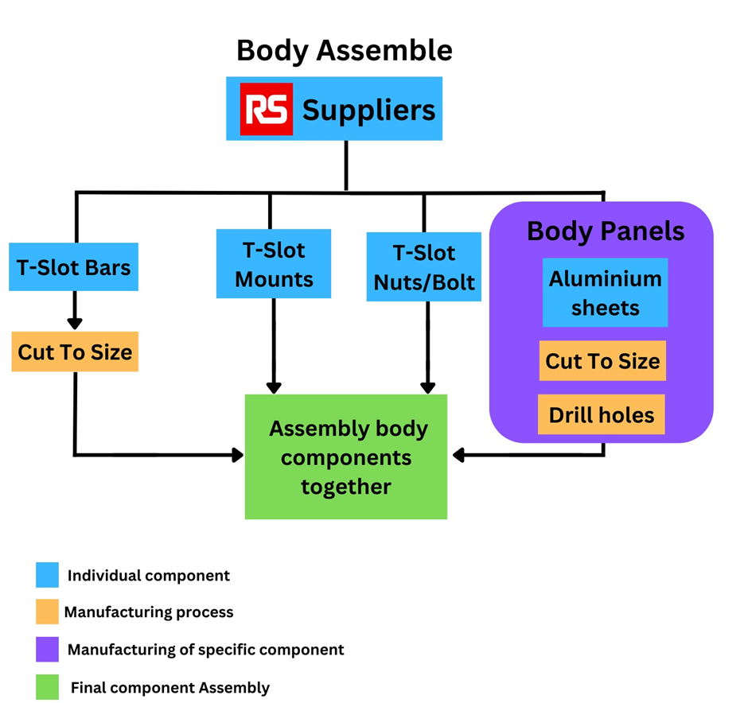

Figure 32 - Overview for manufacturing and assembly process for Body Assemble

Figure XXXX provides an in-depth view of the body assembly process, including the in-house manufacturing of aluminium body panels. This process aims to simplify operations and ensure scalability. By integrating in-house panel production, Activelio AgriTech establishes control an consistency. This depiction reinforces Activelio AgriTech’s credibility and commitment to efficient and high-quality manufacturing.

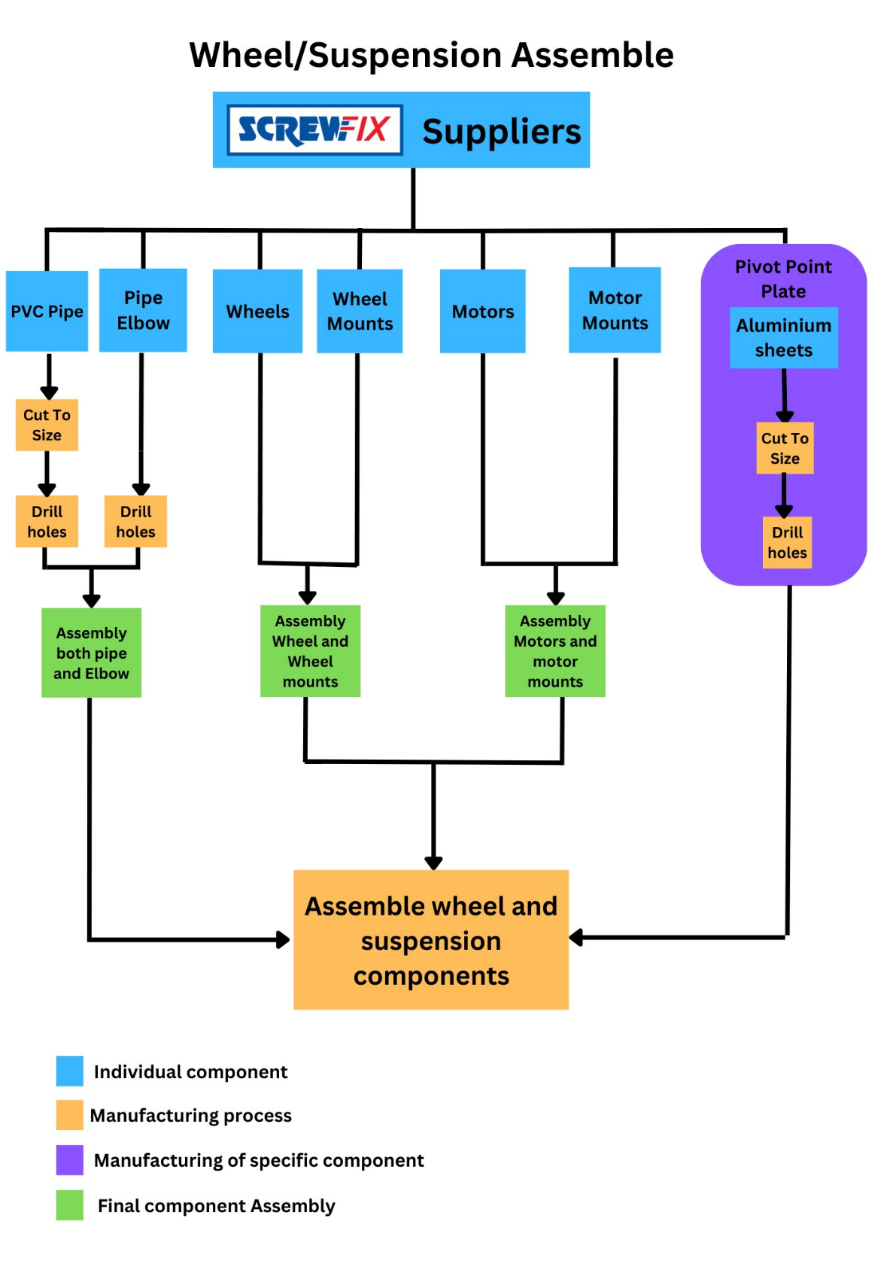

Figure 33 - Overview for manufacturing and assembly process for Wheel/Suspension Assembly

Figure XXXX showcases the assembly process for the wheel and suspension components. This diagram highlights the streamlined manufacturing approach, resulting in shorter lead times and faster delivery. Activelio's commitment to operational efficiency and prompt customer service is evident in this depiction.

Environmental sustainability analysis:

A Life Cycle Assessment (LCA) was undertaken to evaluate the environmental sustainability of our product compared to the use of herbicides. The assessment was divided into two key components. Firstly, it examined the disparity in CO2e emissions between herbicide usage and the operation of the Razor MK1 over a distance of 1 hectare. Secondly, it encompassed a thorough evaluation of CO2e emissions throughout the entire manufacturing process, encompassing stages such as material extraction, transportation, and manufacturing operations. This holistic approach enable the determination of the duration required to offset the environmental impact created and gauge the product's longevity.

Research indicates that herbicide spraying generates approximately 220 kg CO2e per hectare. For the sake of simplicity, this LCA focuses on the CO2e emissions resulting from the laser-based weed removal method. Studies indicate that laser-based weed removal produces approximately 0.02 kg of CO2e per meter. Assuming a weed cut of 5 cm during laser operation, it is estimated that each weed removal emits approximately 0.001 kg CO2e. Considering an approximate density of 1 weed per square meter, this equates to approximately 10,000 weeds per hectare and emits roughly 10 kg CO2e from the laser. Consequently, the laser removal system of the Razor MK1 presents a notable difference of 210 kg CO2e compared to herbicide usage.

<https://spie.org/publications/fg12_p85-86_carbon-dioxide_lasers?SSO=1>

<https://dspace.lib.cranfield.ac.uk/bitstream/handle/1826/3913/Estimation_of_the_greenhouse_gas_emissions_from_agricultural_pesticide_manufacture_and_use-2009.pdf>

The second phase of this Life Cycle Assessment (LCA) aims to evaluate the environmental impact, specifically in terms of CO2e emissions, associated with the manufacturing process of each Razor MK1 robot produced by Activelio. To gain insight into the CO2e emissions generated during the manufacturing of key components, the following components were examined:

Table 13 – CO2 emissions per component

|  |  |
| --- | --- |
| **Components** | **CO2e (kg)** |
| T – Slot bars | 44kg |
| Arduino and Raspberry Pi | 150kg |
| Battery | 15.3kg |
| DC motors | 17.5kg |
| PVC pipes | 4.75kg |
| **Total** | **231.55 kg** |

For aluminium extrusion or T-slot bars, the production of one ton of aluminium emits approximately 16.5 tons of CO2e. Since only 2.73 kg of aluminium is needed for the robot, the CO2e emissions for the aluminium extrusion manufacturing amount to around 44 kg.

<https://alupro.org.uk/sustainability/fact-sheets/carbon-footprint/>

Although specific data for electronic devices like Arduino and Raspberry Pi is lacking, studies indicate that such products typically generate 50 to 100 kg of CO2e. Taking an average of 75 kg CO2e per device is a reasonable estimate.

<https://www.responsiblebusiness.org/media/docs/publications/EICC_PCFAllocationProjectPaper_June2014.pdf>

Regarding lead-acid batteries, research suggests that they produce approximately 65 to 110 kg of CO2e emissions per 40Ah battery. Averaging the emissions to 2.1875 kg CO2e per Ah, the 7Ah battery used in the Razor MK1 results in approximately 15.3 kg of CO2e emissions during manufacturing.

Referring to a study on DC motors, it is estimated that 150 to 200 kg of CO2e is emitted per kilowatt (kW) of motor power. With a total power output of 100W for the Razor MK1's motors, the approximate CO2e emissions amount to 17.5 kg.

<https://theicct.org/sites/default/files/publications/EV-life-cycle-GHG_ICCT-Briefing_09022018_vF.pdf>

Limited data is available for PVC pipe manufacturing emissions. However, the VinylPlus Sustainability Program indicates that producing 1 kg of PVC emits 1.3 to 2.5 kg of CO2e. Notably, this value does not include emissions from shaping PVC into a pipe. Considering the 2.5 kg of PVC used in the Razor MK1, the estimated emissions from PVC manufacturing are around 4.75 kg of CO2e.

<https://www.bpf.co.uk/Media/Download.aspx?MediaId=1078>

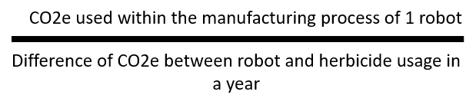

Based on the data collected, the total CO2e emissions for the Razor MK1 manufacturing process amount to 231.55 kg. Utilizing the equation depicted in figure xxxx, it is determined that it would take approximately 1.1 years for the product to generate a positive environmental effect. This indicates that the product has the potential to contribute to environmental improvements within a relatively short timeframe. However, it is important to acknowledge that this LCA analysis involved certain assumptions, which may have affected the accuracy of the investigation. It is important to conduct further research and refine the analysis to enhance the precision of the results.

# **Business Plan:**

## Business Model Canvas:

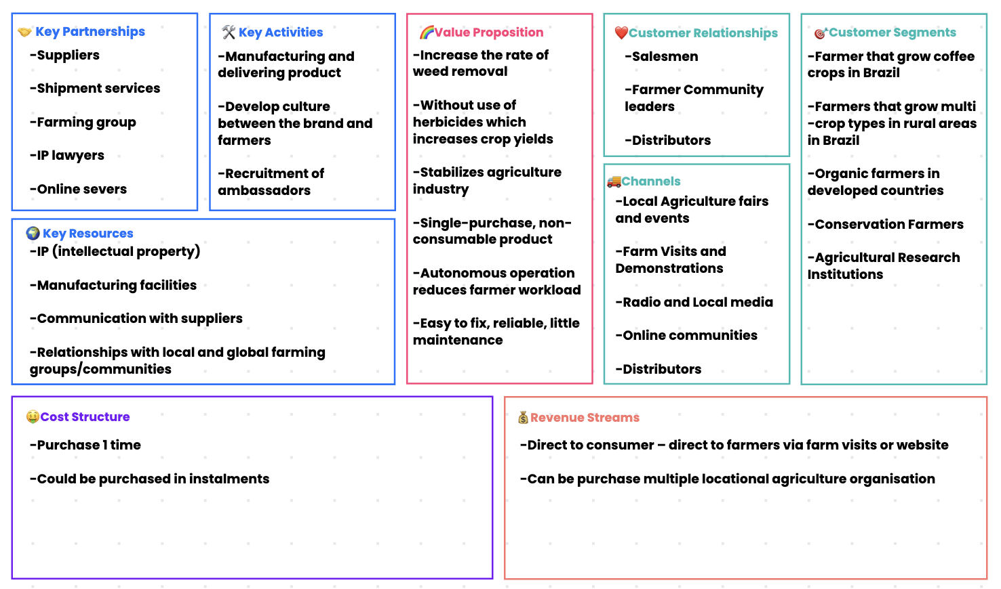

Figure 34 - Activelio Business Model Canvas (BMC)

### Customer Segment

The Razor robot has the potential to cater to diverse customer segments. The following analysis explores the various options, from farmers in rural Brazil who specialize in coffee cultivation to agricultural institutions.

One of the primary customer segments that Activelio aims to pursue are Brazilian coffee farmers. This segment is of vital importance, as it contributes significantly to Brazil's economy, with a valuation of over $40 billion.

<https://www.statista.com/outlook/cmo/hot-drinks/coffee/brazil#:~:text=Revenue%20in%20the%20Coffee%20segment,(CAGR%202023%2D2025)>. – SAME AS YOUR PREVIOUS REFERENCE – ABOUT COFFEE BRAZIL VALUATION

After establishing a secure market in Brazil, Activelio intends to expand into more developed markets, such as Europe and the United States. Developed markets have a higher demand for automation due to limited human resources, and there is a growing preference for organic practices and avoidance of herbicides.

Another customer segment that Activelio aims to target in developed countries is conservation farmers. These farmers are committed to preserving ecosystems, including soil health and biodiversity. This partnership aligns well with Activelio's value proposition, as the Razor robot's laser technology provides accuracy and mitigates soil damage, setting it apart from other strategies such as mechanical systems.

Lastly, agricultural research institutions such as The Agricultural Research Institute (ARI) represent an intended customer segment. These institutions prioritize sustainable and innovative practices to minimize environmental impact. The use of the Razor MK1 aligns with their research and development goals.

<https://pakobserver.net/ari-tarnab-organizes-olive-fair/>

### Value Propositions

Activelio aims to create multiple value propositions to enhance the utility of the Razor MK1. This includes increasing the rate of weed removal without the use of herbicides, thereby increasing crop yield and ensuring long-term sustainable profitability for Brazilian farmers. This approach helps maintain the cost and pricing of Brazilian agriculture in a sustainable manner.

The product is designed to be reliable and easy to fix in the event of a breakdown, using easily accessible components. The autonomous operation and minimal maintenance requirements of the robot reduce the workload for farmers, allowing them to focus on other areas of their farms.

### Channels

To effectively reach the wide market, several channels are applicable for the success of the Razor MK1 on a global scale. One approach is showcasing the robot at local agriculture fairs and events, where a high concentration of potential customers can be found, facilitating multiple sales in a single day.

Direct farm visits and live demonstrations are another effective channel. Through secondary research, Activelio can identify potential customers and organize product demonstrations. Offering a free weed removal service can showcase the capabilities of the Razor MK1.

Local media, such as targeted newspapers and radio broadcasting, can be utilized to acquire customers in rural Brazil, considering limited access to modern advertising methods like social media marketing. This approach can help establish and validate the Activelio brand before conducting direct farm visits.

While online methods are limited in rural Brazil due to restricted social media access, cultivating online agriculture communities such as forums can be employed to acquire customers actively seeking innovative weed removal products.

Another channel for customer acquisition is the use of distributors, serving as middlemen to independently sell the product. This approach allows Activelio to focus more on customer retention and the development of additional products.

By effectively targeting these customer segments and employing appropriate channels, Activelio aims to establish a strong market presence, provide value to customers, and drive the adoption of the Razor MK1 in the weed removal industry.

## SWOT Analysis:

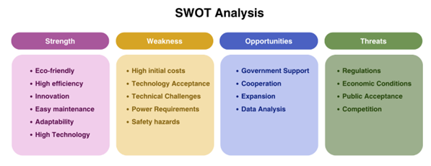

Figure 35 - Activelio SWOT analysis

### Strengths

Compared to other weed control machines and traditional weed control methods, Activelio AgriTech’s Ray-Zer Mk1 is more environmentally friendly. Employing the innovative laser weed removal technique, this offers high efficiency, positioning it competitively in the agricultural sector. The integration of the Rocker-Bogie system allows it to adapt to various terrains in agricultural fields, ensuring optimal performance and adaptability. Furthermore, the use of easily accessible and replaceable materials facilitates simplify maintenance procedures, thereby enhancing the robot’s overall reliability.

### Weaknesses

This project faces the challenge of high development costs due to the integration of complex technologies. Also Brazil is a developing country, the introduction of high-tech solutions may be met with resistance from traditional famers who are accustomed to conventional methods. The use of laser to carry certain inherent risks, as they have the potential to cause unintended harm to other organisms in the field. Moreover, in poor rural areas, endurance and charging become a major challenge, so it’s advantageous to design solar panels.

### Opportunities

The global AgriTech market is experiencing significant growth. Governmental support for sustainable farming practices can create a favorable environment. Furthermore, Activelio can collaborate with high-tech institutions and academic organizations to conduct research on the weed recognition technology and navigation etc. These partnerships can not only focus on technological advancements but also can contribute to data collection and exploration in the field of plant ecology.

### Threats

Regulatory factors surrounding laser technology usage may impose compliance challenges. And the competitive AgriTech landscape introduces the risk of rival companies developing comparable or superior solutions. Furthermore, economic fluctuations and uncertain conditions pose risks of reduced investments in agricultural technology. To effectively mitigate these threats, Activelio must prioritize regulatory compliance, address public concerns through transparent communication and education.

Based on Figure xx analysis, Activelio adopts a sustainable growth strategy (SO). The SO strategy focuses on leveraging strengths to pursue sustainable growth. Activelio should continue to invest in research and development, collaborate with High-Tech institutions to enhance the technology, and develop strategic partnerships to expend market reach. This also allows to reduce the threat of peer competition and create own proprietary technology.

## Exploration of potential markets:

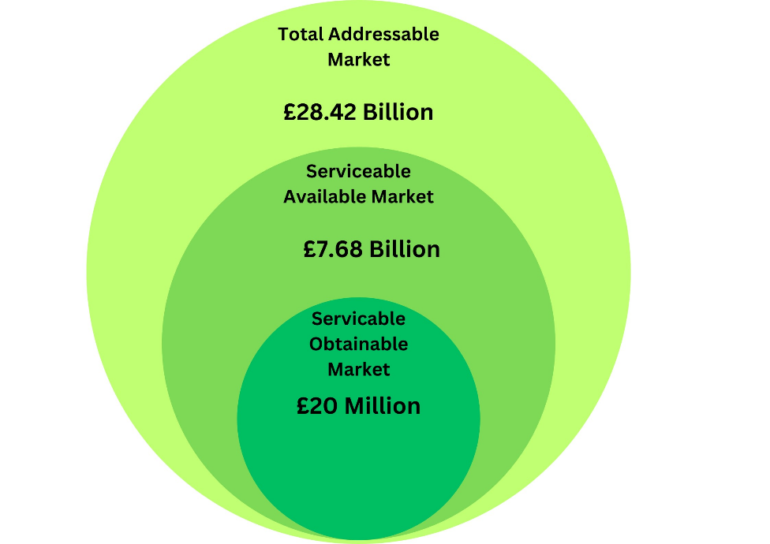

Figure 36 - Activelio market capitalisation

A comprehensive TAM (Total Addressable Market), SAM (Serviceable Addressable Market), SOM (Serviceable Obtainable Market) analysis was conducted to evaluate potential market opportunities beyond Brazil. Research reveals that the global weed removal market is valued at £28.42 Billion, as illustrated in Figure XXXX. The primary method employed in this market is herbicide application, accounting for a significant portion of its value.

<https://www.businesswire.com/news/home/20210916005897/en/Global-47.09-Bn-Herbicides-Market-to-2025-2030---ResearchAndMarkets.com>

The SAM, valued at £7.68 Billion, represents the portion of the market that Activelio aims to capture by expanding its operations into South America and Europe. This expansion strategy encompasses both developing and developed markets to maximize revenue potential for the company.

<https://www.marketdataforecast.com/market-reports/latin-market-glyphosate-market>

<https://www.marketdataforecast.com/market-reports/europe-herbicides-market>

Furthermore, the SOM analysis focuses on identifying the realistic and achievable market share within a specific timeframe. Activelio expresses confidence in attaining £20 Million within a 10-year period. This confidence stems from the competitive landscape of the weed removal industry and the limited adoption of alternative methods by farmers. Activelio's goal of eliminating herbicide usage in agriculture poses a challenge, but it also presents an opportunity to capture market share by providing innovative and sustainable solutions.

## Finance Projections:

Figure 37 - Three-year revenue and net profit projections

Figure xxx presents the projected revenue and net profit for the first three years of Activelio's operation. In the initial year, a loss of approximately £330,891 is expected, which is attributed to the capital-intensive nature of the hardware business and the associated high operating costs indicated in figure xxx. However, in the second and third years, Activelio anticipates generating net profits of approximately £415,844 and £1,704,061, respectively. This growth is attributed to the expansion into more developed markets, targeting larger landowners and institutions who are projected to place bulk orders for multiple robots. As illustrated in figure xxxx, the total units sold are expected to increase significantly, starting from 279 units in the first year and reaching 2,310 and 5,700 units in the second and third years, respectively.

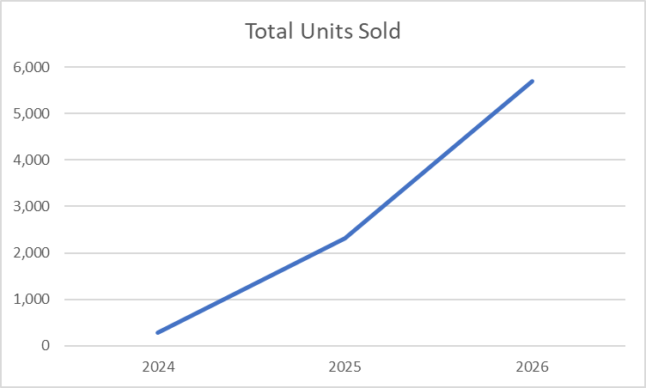

Figure 38 - Three-year sales volume projections

It is important to consider that as sales volume increases, so do costs. Consequently, Activelio has determined that a 41% profit margin will be maintained to account for this growth. This profit margin also establishes important breakeven targets, which are expected to be achieved in the second and third years, as depicted in Figure xxxx.

Table 14 - Break-even point projections

|  |  |  |
| --- | --- | --- |
| **Year** | **Break-Even Target** | **Predicted to Achieved (Y/N)** |
| 2024 | 1083 Units | N |
| 2025 | 1300 Units | Y |
| 2026 | 1560 Units | Y |

As outlined in the Kickstarter campaign, Activelio is seeking funding of £100,000, which will be allocated across two categories. 25% of the funding will be dedicated to further product development and testing, ensuring that the product design is fully prepared for commercial implementation. The remaining 75% will cover setup costs, as shown in Figure xxx.

Table 15 - Initial start-up costs

|  |  |
| --- | --- |
| **Set-up cost** | **Cost** |
| Manufacturing Equipment | £43,900 |
| Facility set-up | £8,000 |
| Intellectual | £10,240 |
| Software and IT infrastructure | £380 |
| AI Training | £5,000 |
| Financial Buffer | £7,750 |
| **Total** | **£75,000** |

For the initial seed round of £100,000, a 10% equity exchange is anticipated, resulting in a pre-money valuation of £1 million. Following the completion of the setup and testing phase, a subsequent Series A funding round of £500,000 will be pursued at a pre-money valuation of £2.5 million. This additional funding is crucial to sustain the business after the first year, which is projected to incur a loss of over £300,000 due to the running costs highlighted in Figure xxxx.

Table 16 - Activelio operational costs

|  |  |  |
| --- | --- | --- |
| **Running Cost** | **Cost per Month** | **Cost per Year** |
| Manufacturing Maintenance | £10,000 | £120,000 |
| Salaries | £22,000 | £265,000 |
| Utilities | £2,200 | £26,400 |
| Rent | £1,000 | £12,000 |
| Regulatory Compliance | £130 | £1600 |
| Business Insurance | £118 | £1,416 |
| Admin | £1,695 | £20,340 |
| **Total** | **£37,143** | **£445,716** |

Activelio aims to achieve an exit within the first eight years of operation, with a valuation of £20 million, providing a return on investment (ROI) of 19x for the seed round and 7x for the Series A round. As Activelio expects to achieve cash positivity from the second year onwards and does not anticipate requiring further investment, investors can expect minimal dilution of their stake in the company.

## Critical Analysis of Risks:

It is important to thoroughly assess the risks associated with starting a business involving components that may pose significant risks, particularly in the agricultural environment, as depicted in Table XXX. Consequently, the Razor MK1 robot has been designed to mitigate many of these risks. The key measures implemented include:

* Laser Safety: The Razor MK1 is equipped with a feature that automatically halts laser operation if the robot is in an incorrect orientation. This precautionary measure ensures the prevention of injuries to users and wildlife.
* Durability and Reliability: The robot has been built using high-quality components, ensuring its robustness and reliability. By employing top-tier materials and construction techniques, the frequency of breakdowns during operation is minimized, allowing for smooth and uninterrupted functioning.
* Emergency Assistance: Each Razor MK1 system is equipped with a designated emergency contact, providing immediate access to professional help in the event of a serious injury or unforeseen circumstance.

By incorporating these safety measures, Activelio aims to maintain a secure and controlled environment for both users and the surrounding ecosystem

|  |  |  |  |  |  |  |  |  |
| --- | --- | --- | --- | --- | --- | --- | --- | --- |
| **Risk Type** | **Description** | **Probability (L/M/N)** | **Impact (L/M/H)** | | | **Risk Treatment** | **Contingency Plans** | **Risks Degree** |
| **Time** | **Cost** | **Quality** |
| Safety risk | Lasers can pose a risk to humans and wildlife while in operation. E,g Skin and eye injury etc. | M | L | H | H | It is necessary to ensure that all operators wear appropriate personal protective equipment such as gloves and safety glasses at all times while operating. | If the laser system becomes unstable or there is accidental exposure, the user should know how to shut down the system immediately to avoid possible injury. | **H** |
| Technical risk | System failures may occur. E.g  Laser, motion and AI | M | M | M | M | Regular maintenance and inspections are used to prevent system failure. | Technical support team is available to assist remotely or on site if the user is unable to solve the problem themselves. | **M** |
| Legal and compliance risk | In some countries, stringent laws and regulations govern the use of lasers. | L | L | M | L | Activelio will target countries where laser use in agriculture is allowed and secure legal and insurance protection will be used to mitigate risk during an incident.  . | Transparency will be maintained in all areas by providing the regulator with all the information required to demonstrate compliance with the robot. | **L** |
| Cultural Risk | Early adoption may be difficult especially in conservative communities. | M | M | M | M | Demonstrate the benefits of robots to the general public through public education and awareness campaigns to increase their acceptance. This can be done through case studies, presentations, lectures, etc. | To highlight the robot's benefits to the community, engaging in discussions with community leaders and influencers is necessary. If there is resistance, alternative marketing approaches or initial trials in different areas can be considered to showcase success before returning to the original location. | **M** |

Table 17 - Product risk register

* The probability and impact (L/M/H) in the table represent Low, Medium and High; where the three-colored area represents the degree of risk severity. (Red represents high risk, yellow means medium risks and green represents low risk

# **Discussion and Feasibility:**

# **References:**

# **Appendices:**

## Appendix 1:

## Appendix 2: